

|  |  |  |  |
| --- | --- | --- | --- |
| **Qualification** | | **Module Number and Title** | |
| HND in Computing/ HND in Software Engineering (Level 5) | | SED5212 Web Application Development | |
| **Student Name & No.** | | **Assessor** | |
| Hakeema Ismail (KD/HNDCSE/49/32) | | Gihan Herath | |
| **Hand out date** | | | **Submission Date** |
| 3/5/2021 | | |  |
| **Assessment type**  Course work | **Duration/Length of**  **Assessment Type**  Practical project/Report | | **Weighting of Assessment**  100% |

|  |
| --- |
| **Learner declaration** |
| I certify that the work submitted for this assignment is my own and research sources  are fully acknowledged. |

|  |  |  |  |
| --- | --- | --- | --- |
| **Marks Awarded** | | | |
| First assessor | |  | |
| IV marks | |  | |
| Agreed grade | |  | |
| Signature of the assessor |  | Date |  |

**Feedback Form**

**International College of Business & Technology**

**Module:**

**Student:**

**Assessor:**

**Assignment:**

**Strong features of your work:**

**Areas for improvement:**

**Marks Awarded:**

**Course work**

**Learning outcomes covered**

1. Understand the fundamentals of designing and developing an effective website
2. Planning and designing a website
3. Develop effective website for business organization
4. Evaluate and test the website

**Scenario and the Task**

# Introduction

World wide web is a very mature and popular technology which is used by every sector in the world. For this assignment, you need to select a book author of your liking and develop a website for that author. The following are some main requirements but you have the freedom of adding more features accordingly.

1. Home page.
2. Gallery.
3. Shopfront for products with one or more images, price and a small description.
4. Contact us page with a contact form.
5. About us
6. News and promotion with at least three or more posts with proper articles.

**Website should full fill bellow mentioned requirements**

* Appropriate validation techniques to made information clean and clear.
* Design data entry form with validations
* User friendliness
* Good navigational structure
* Well captioned layout designs and colour schemes

***Note:*** *More functionality can be added with the assumptions*

1. An extensive process of requirements gathering and analysis is one of the key success factors of the web project. Use suitable requirement gathering methods to understand the user’s expectations. Analyze similar websites also very helpful in this situation. Build relevant and detailed requirements specification document based on collected information

**(Marks 15)**

1. Design an interactive web application for the given scenario. Design should include a home page and a minimum of six web pages. ***(*Marks 20)**
2. Implement highly interactive web application for the above scenario ***(*Marks 10)**
3. Demonstrate implemented system. ***(*Marks 20)**
4. Web site testing and evaluation are very important to make sure web site is error-free and your company makes a good impression on current and potential customers. Test your website using appropriate techniques. ***(*Marks 15)**
5. Prepare the documentation covering given tasks. ***(*Marks 20)**

**Assessment Criteria**

|  |  |
| --- | --- |
| **This submission will be assessed as follows** | **Depth of the task** |
| TASK 1 | Use of appropriate techniques to gather requirements and analyze them, prepare SRS. |
| TASK 2 | Design a web site. Design should include home page, minimum six web pages. |
| TASK 3 | Use different technologies such as markup languages, scripting languages, styling techniques. Follow proper coding standards |
| TASK 4 | Error free user friendly, fully functional system |
| TASK 5 | Test and evaluate developed web site using different testing techniques and evaluation techniques. |
| TASK 6 | Standard documentation follow the report guideline, clear evidence for all the tasks, conclusion and timeline |

|  |  |  |
| --- | --- | --- |
| **This submission will be assessed as follows** | **Total marks Allocated** | **Marks obtained by the student for the answer provided** |
| TASK 1 | 15 |  |
| TASK 2 | 20 |  |
| TASK 3 | 10 |  |
| TASK 4 | 20 |  |
| TASK 5 | 15 |  |
| TASK 6 | 20 |  |
| **Total Marks** | **100** |  |

Marking Scheme

|  |  |  |
| --- | --- | --- |
| **This submission will be assessed as follows** | **Total marks Allocated** | **Marks obtained by the student for the answer provided** |
| **Task 1 Requirement gathering and analyzing** | **Marks 15** |  |
| **Poor**   * No proper requirement gathering * SRS no proper format and contents | 0-6 |  |
| **Satisfactory**   * Use of one fact finding method * Compare one similar web site with developed site. * SRS document with project scope, solution, functional and non-functional requirements. | 6-9 |  |
| **Good**   * Use of more than one fact-finding technique with attached evidence. * Compare more than one similar web site with developed site use of proper criteria. * Use of proper format for the SRS document * Appropriate detailed contents under each heading of the SRS document. | 9-11 |  |
| **Excellent**   * Strong justification of selecting appropriate fact-finding techniques. * Detailed similar web site comparison with valid arguments. * Critical evaluation all the functions mentioned in the SRS documents. | 11-15 |  |

|  |  |  |
| --- | --- | --- |
| **Task 2 System design** | **Marks 20** |  |
| **Poor**   * No proper web site design * Too much of information and inappropriate colors * Inconsistency throughout web site * Irrelevant content | 0-8 |  |
| **Satisfactory**   * Design a web site with minimum six pages with relevant content. * Use of images and colures | 8-12 |  |
| **Good**   * Style consistent throughout the website. * Appropriate use of images, colors and layout designs. * Use of site map | 12-14 |  |
| **Excellent**   * Evaluate the effectiveness of the web site using proper techniques. * Strong justification of achieving company goals. * Use of design framework | 14-20 |  |
| **Task 3 Program implementation** | **Marks 10** |  |
| **Poor**   * No proper standard coding * Inefficient code | 0-4 |  |
| **Satisfactory**   * Code samples to prove use of different technologies to build the web site. | 4-6 |  |
| **Good**   * Use of structured codlings * Enhance the readability and maintainability use of comments and proper naming conventions * Use of proper evidence to improve all the answers .very clear examples of code pars and other screen shots appropriately from own system. | 6-7 |  |
| **Excellent**   * Efficient coding proper use of data types, variables, constants and other structures with proper Justifications. * Use of new technologies with proper justification * Use of very clear innovative assumptions | 7-10 |  |
| **Task 4 System demonstration** | **Marks 20** |  |
| **Poor**   * System with syntax and logical errors * Poor implementation of core functions given in the SRS(implementation of one function or none | 0-8 |  |
| **Satisfactory**   * Error free functional web site. * Few working functions | 8-12 |  |
| **Good**   * Fully functional Responsive web site * Use of different technologies (markup languages, Scripting, styling techniques) * User friendliness of the interfaces use of appropriate user-friendly messages easy navigations. * Appropriate use of client side validation techniques | 12-14 |  |
| **Excellent**   * Implementation of innovative ideas * Creative use of user interfaces * Advanced use of new technologies for the implementation of the web site | 14-20 |  |
| **Task 5 Web site testing and evaluation** | **Marks 15** |  |
| **Poor**   * No or very poor evidence for testing * No proper format to document testing | 0-6 |  |
| **Satisfactory**   * Test the web site using one testing techniques * Test results attached with the document. * Basic user feedback report | 6-9 |  |
| **Good**   * Use of different techniques to test the web site backed by * Collect user feedback using appropriate justified technique. Evidence should be attached. * User feedback report with strong evaluation of user feedback. | 9-11 |  |
| **Excellent**   * Use of different testing tools for web site testing * Recommendations for the future enhancement based on user feedback and your own valid arguments. * Evidence of critical analysis of test results and conclusion. Any discrepancy and the given solution. * Use of different tools for testing. | 11-15 |  |
| **Task 6 Technical documentation** | **Marks 20** |  |
| **Poor**   * Poor structure no clear examples and ambiguous contents. * No evidence of referring range of sources * Poor conclusion | 0-8 |  |
| **Satisfactory**   * Acceptable standard of documentation with page numbering and table of contents. * Evidence for referring range of sources to complete given tasks * Acceptable conclusion | 8-12 |  |
| **Good**   * Professional standard of documentation backed by clear examples and good explanation * In text and body citation using Harvard reference. * Proper conclusion with clearly mentioned program strengths and weakness. * Use of time line for the management of the project | 12-14 |  |
| **Excellent**   * Excellent academic writing throughout the documentation. * Detailed timeline with proper justification | 14-20 |  |
| **Total Marks** | **100** |  |

**Submission Guidelines**

* Submission format: Report
* Paper Size: A4
* Words: 3000 words
* Printing Margins: LHS; RHS: 1 Inch
* Binding Margin: ½ Inch
* Header and Footer: 1 Inch
* Basic Font Size: 12
* Line Spacing: 1.5
* Font Style: Times New Roman
* **Referencing should be done strictly using Harvard system**

**Acknowledgement**

First off, I would like to express my heartiest gratitude to my lecturer, Mr. Gihan Herath for being a good guide for this module, by answering my questions and clarifying my doubts whenever necessary. The knowledge he has provided us with, is priceless. Next, I would like to thank my parents and friends, without whose support, I wouldn’t have been able to complete this assignment. Last but not the least, many thanks to ICBT for being a place that constantly provides me with new knowledge. Thank you!

**Executive summary**

A book website for an author has been built for this assignment. This website has been built using HTML, CSS, JavaScript and jQuery and it is a highly functional and interactive website. First of all, the book websites of other authors has been analyzed and information has been extracted from them. Then a design plan was drawn out in which the features of every page in this website was discussed thoroughly with their justification. Next the sitemap and the wireframes were drawn for every page of the website, including their desktop view and mobile view. Once a clear idea was taken from those diagrams, the website was built accordingly using various web technologies. Once the website developing was done, the website was hosted and tested using various testing tools and the screenshots of the results were shared here.

**Table of contents**

Introduction…………………………………………………………………………………16

Task 01………………………………………………………………………………………17

Analyzing the authors’ websites...................................................................................…...17

Designing the websites…………………………………………………………………….31

Task 02………………………………………………………………………………………34

Sitemap……………………………………………………………………………………..34

Wireframes…………………………………………………………………………………35

Task 03……………………………………………………………………………………….48

The HTML Document……………………………………………………………………...48

The header section………………………………………………………………………….49

The vertical navbar………………………………………………………………………….52

Buttons………………………………………………………………………………………55

Embedding the YouTube Video…………………………………………………………….57

Review section……………………………………………………………………………..59

Gallery………………………………………………………………………………….…..61

FAQ page……………………………………………………………………………….…..65

Contact us page form………………………………………………………………………….68

Task 05………………………………………………………………………………………..71

Checking for HTML Validation…………………………………………………………….71

Link checker…………………………………………………………………………………77

Browser-compatibility testing…………………………………………………………………79

Website Speed Testing…………………………………………………………………………81

Responsive Testing ……………………………………………………………………………85

**Introduction**

The expectation of this assignment is to build a functional website for a book author, with a minimum of six pages which are: Home, About, Contact us, Shop, Gallery and News. These are the minimum requirements and more pages can be added. The website is supposed to be highly interactive and user friendly, and this documentation is testimony to how the website has been slowly developed by backing its development with relevant assumptions, and getting ideas from similar websites. After the analyzing of similar websites, wireframes are drawn, and the website is built accordingly. Lastly testing is done to ensure the quality of the site.

**Task 01**

Analyzing other authors’ websites

**Dan Brown**

**URL:** <https://danbrown.com/inferno/>

**Pages:** Dan, News, Media, Secrets, Films, Novels

**Content:** The homepage has a picture of the author with a description about him below it, and two links, which lead to the gallery and a downloadable press kit. There is a section with the images of the published books with a small description. Clicking on a picture will lead to a page with a larger description about the book and with options to buy it or download an excerpt of it. Further, down, there is a YouTube video of the authors’ writing class. Below it, there are separate sections for news, media and films with pictures and links, which lead to other pages.

**Colors:** The entire website has been designed according to a color theme of black and orange with little bits of pale yellow.

**Navigation:** It is a one page website. When the links are clicked, the user is navigated to the relevant part of the page. The navigation bar for the website on desktop screen is horizontal. In mobile screen the website gives a vertical navigation bar.

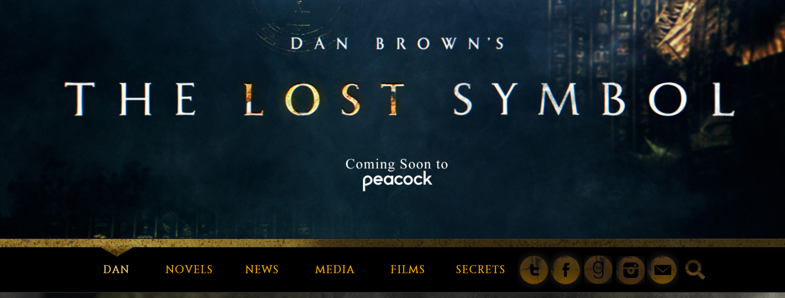

Figure 1.0



Figure 2.0

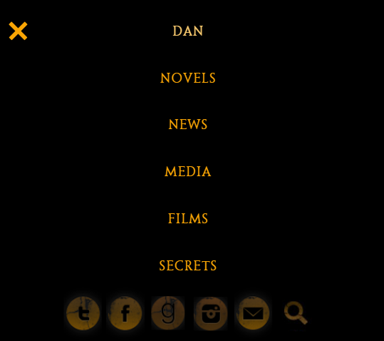

Figure 3.0

**Responsive mode:**

When the site is in responsive mode, the pictures become arranged column wise. In addition, the pictures of books that were arranged three by three in each row become arranged two by two.

**Technologies used:**

According to w3techs.com, which analyzes the site info of websites, these are the technologies used when building this website.

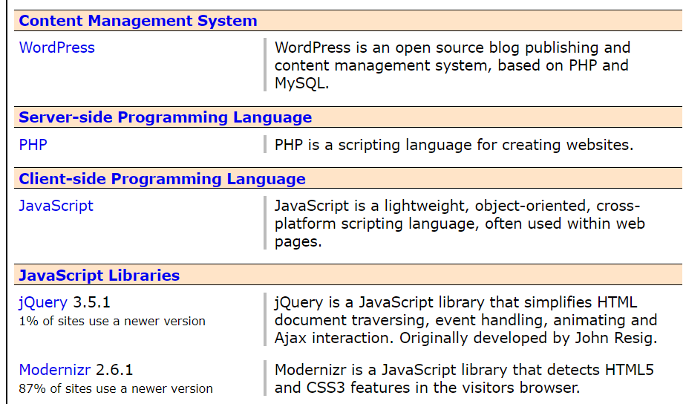

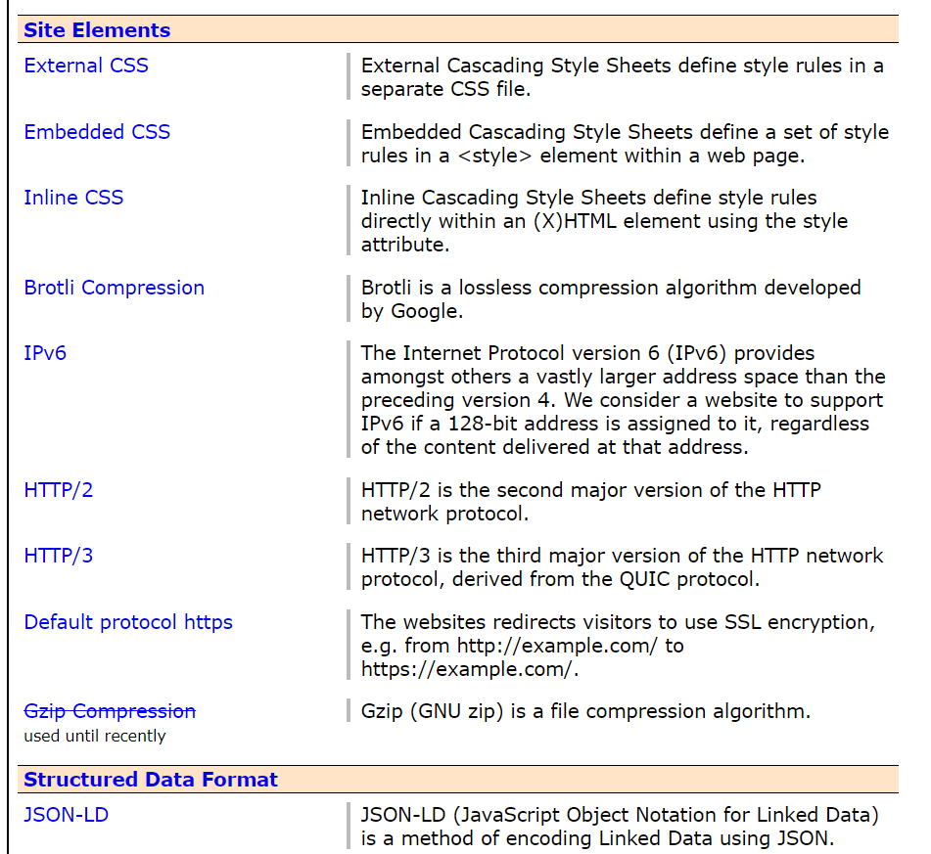

Figure 4.0

**Anthony Horowitz**

**URL:** <https://www.anthonyhorowitz.com/>

**Pages:** Home, About Anthony, Work, FAQ, Gallery, Shop, Forum, Extras, News, Events

**Content:** The top section of the homepage of the website has the picture of the author with his credentials. The next section has the author’s newest released book with a picture and a description with a link to read more about it. Further down are pictures of the authors’ other works. Clicking on those pictures will lead to the Amazon page of the relevant book. The footer of the home page has icons that lead to the authors’ socials, and a few links, which lead to articles by the author. The “About Anthony” page contains a picture and description of the author. The shop page has separate sections for different series, and when the pictures are clicked they lead to the respective Amazon pages. News page contains posts with a picture and a “Read more” button, which when clicked will redirect to the respective news article. Work, FAQ, Extras etc. have articles and pictures in them column wise and row wise.

**Colors:** Yellowish orange, grey and black.

**Navigation:** It is a multi-page website with a horizontal nav bar. Clicking on the links in the navbar will direct the user to the respective pages.

**Responsive mode:**

When the site is in responsive mode, the horizontal navbar get stacked up in the following manner.

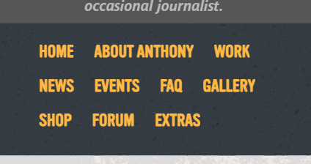

Figure 5.0

The pictures that were arranged three by three in a row, become arranged two by two. This paves way to a better user experience.

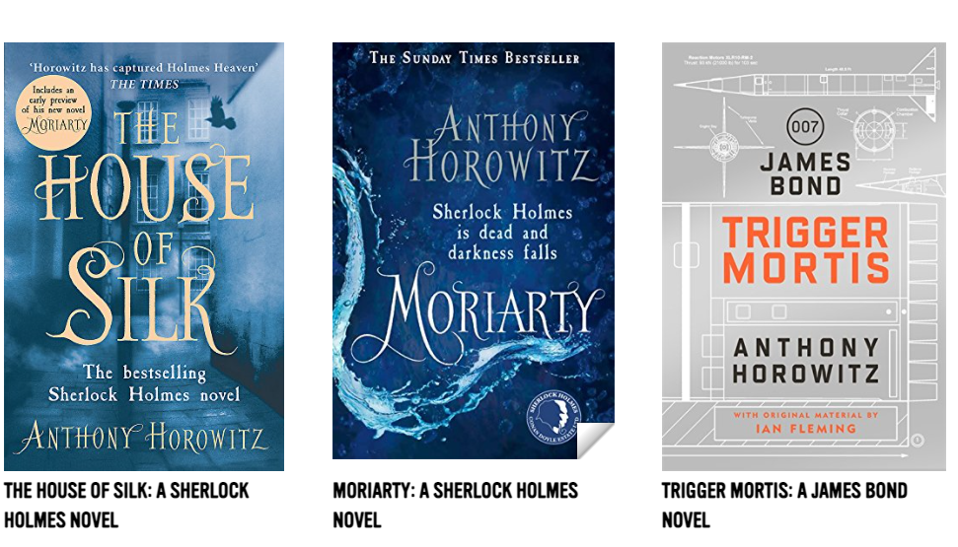

Figure 6.0

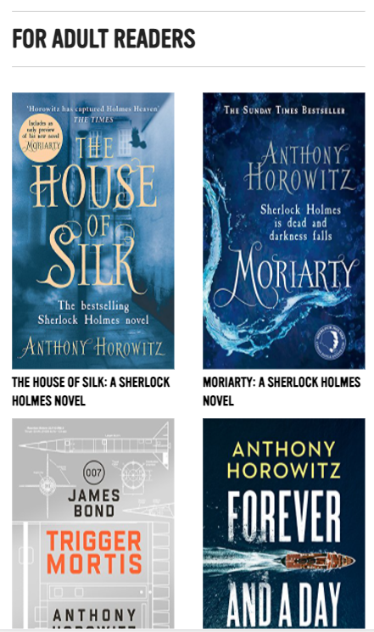

Figure 7.0

**Technologies used:**

According to w3techs.com, which analyzes the site info of websites, these are the technologies used when building this website.

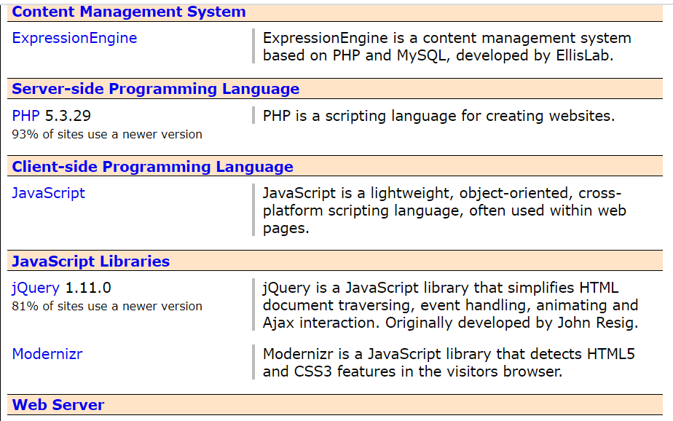

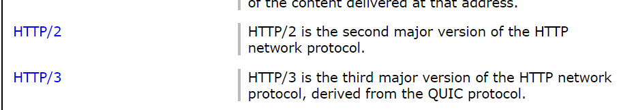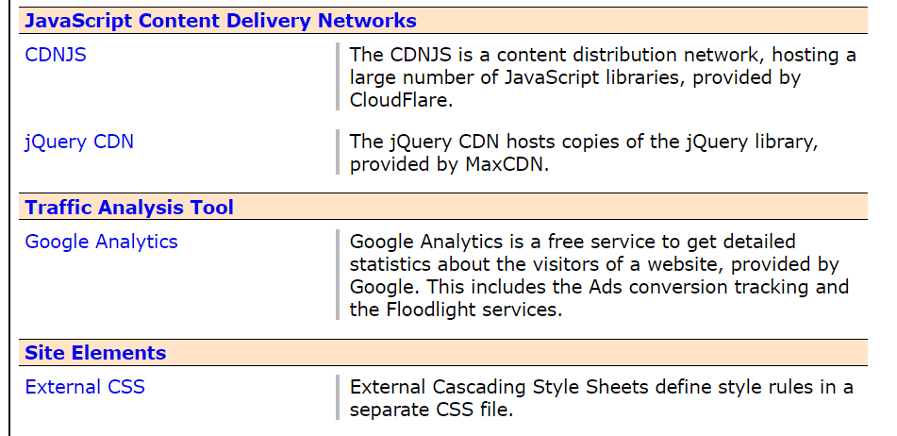

Figure 8.0

**J.K.Rowling**

**URL:** <https://www.jkrowling.com/>

**Pages:** Home, News, Writing, Answers, About

**Content:** The home page is filled with pictures and links that direct to different pages of the website. They’re filled with the most recent news. The News and Answers page has posts with the most recent post at the top and the older ones at the bottom, arranged column-wise. The “Writing” page has pictures of books which when clicked will direct to a page with the description of the book. And the about page has a description of the author with her picture.

**Colors:** Brown, White

**Navigation:** It is a multi-page website with a horizontal nav bar. Clicking on the links in the navbar will direct the user to the respective pages.

**Responsive mode:**

In responsive mode, the horizontal navbar disappears to show the hamburger icon, which when clicked will with a dropdown menu. The posts/pictures that were arranged in a row besides each other, arrange themselves column wise one after the other.

**Technologies used:**

According to w3techs.com, which analyzes the site info of websites, these are the technologies used when building this website.

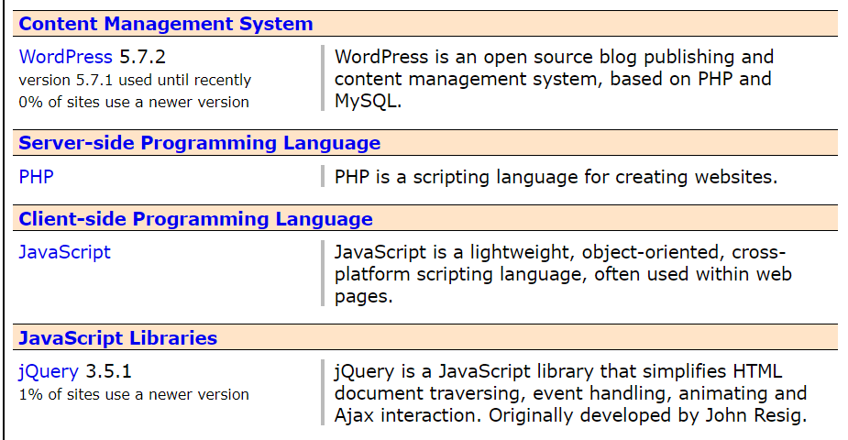

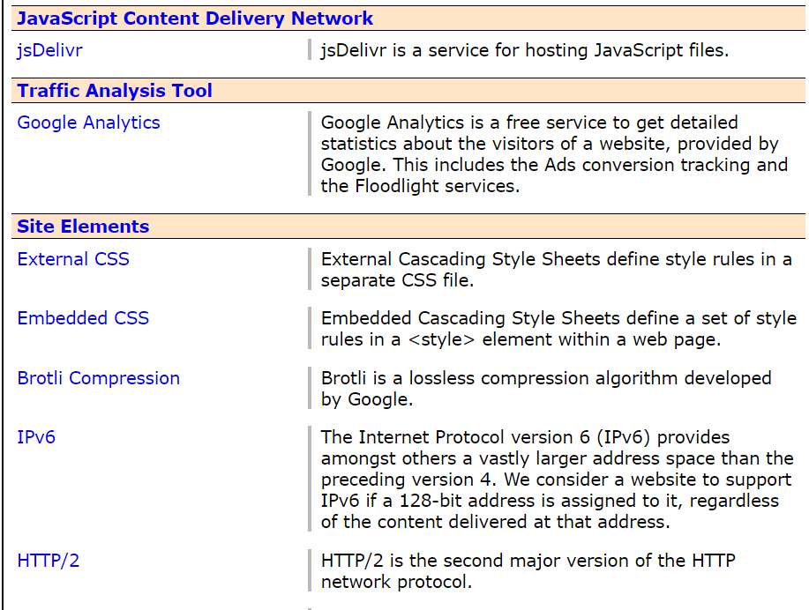

Figure 9.0

**Veronica Roth**

**URL:** <https://veronicarothbooks.com/>

**Pages:** Home, Bio, Classroom, Books, News, Events, Contact Us

**Content:** The top section of the home page has a slideshow with the authors picture, recent news, recent event etc which the user can navigate between. The middle section has a description about the author’s recent release. The third section also has a slideshow with some videos and pictures. It is a multi-page website with a horizontal navbar with links that will direct to the respective page when clicked. The Books page has pictures of books which when clicked will direct to a page with a description of the book and the option to order the book from different bookstores.

**Colors:** White, grey, blue

**Navigation:** It is a multi-page website with a horizontal nav bar. Clicking on the links in the navbar will direct the user to the respective pages.

**Responsive mode:**

When the site is in responsive mode, the navbar becomes vertical with a dropdown menu.

**Technologies used:**

According to w3techs.com, which analyzes the site info of websites, these are the technologies used when building this website.

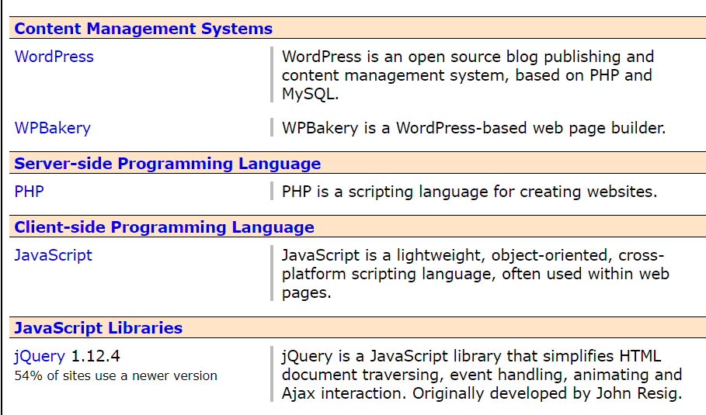

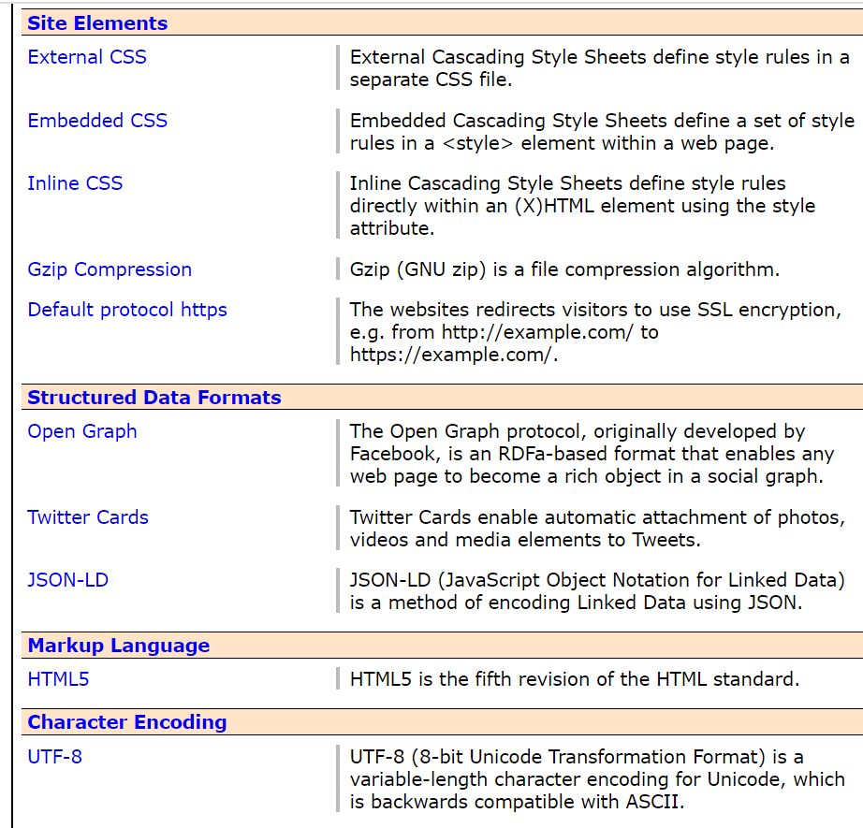

Figure 10.0

**Mike Chen**

**URL:** <https://www.mikechenbooks.com/>

**Pages:** Home, About, Books, Events, Updates, Newsletter, Contact

**Content:** The home page has the recent release of the author with a “buy now” option. The “About” page consists of a picture of the author and a description. Each web page is short, and the content is given in a simple manner.

**Colors:** Brown, Black, White

**Navigation:** It is a multi-page website with a horizontal nav bar. Clicking on the links in the navbar will direct the user to the respective pages.

**Responsive mode:**

When the site is in responsive mode, the navbar becomes vertical with a dropdown menu.

**Technologies used:**

According to w3techs.com, which analyzes the site info of websites, these are the technologies used when building this website.

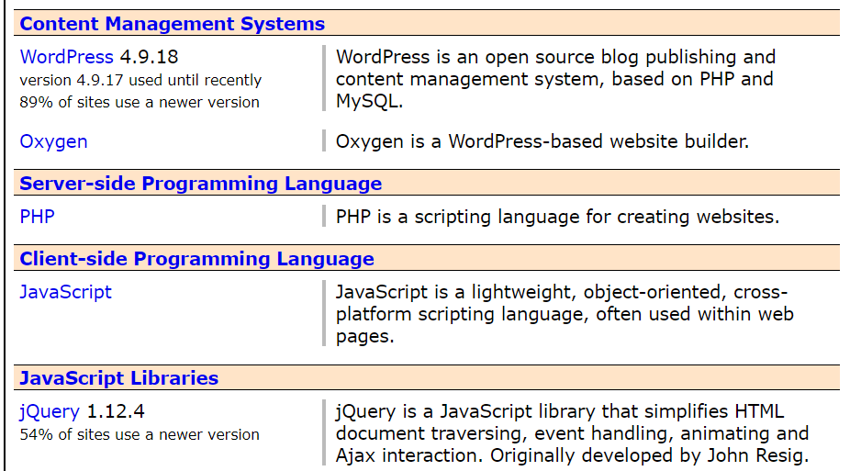

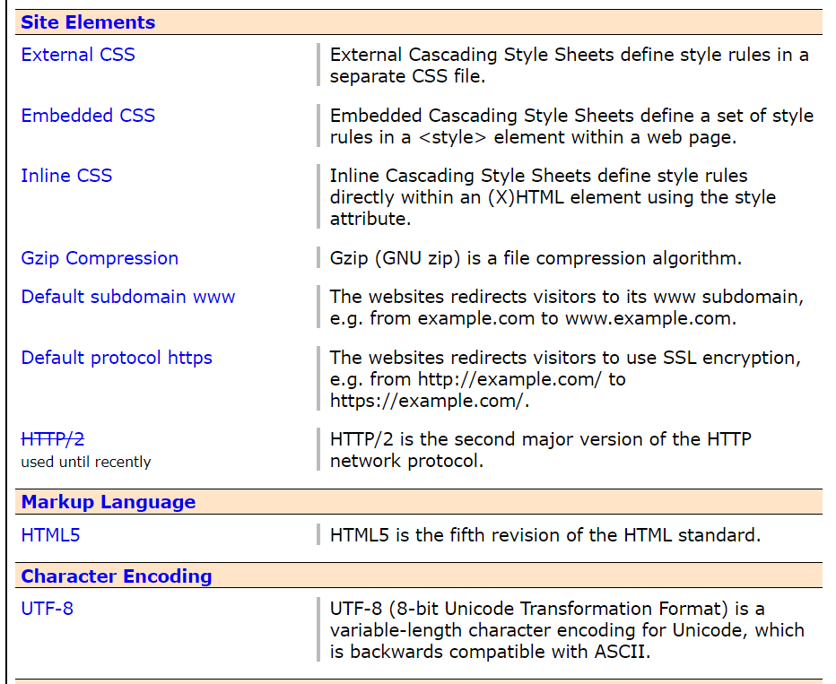

Figure 11.0

**Suzanne Collins**

**URL:** http://www.suzannecollinsbooks.com/index.htm

**Pages:** Home, Works, Biography, Interview

**Content:** The home page consists of the latest release with all the review that is has received. The page is divided into three columns and this is in the middle column. The right column has a small welcome message from the author, and the left column has the critical acclaim that the author has received for her works. And there are quick links to navigate to various bookstores to buy her books. The “Works” page consists of pictures and descriptions of her books. The Biography page contains a picture of the author along with her bio. The interview page consists of a picture of the author and the interview that she had.

**Colors:** Light orange, light green

**Navigation:** It is a multi-page website with tabs which direct to the respective pages .

**Responsive mode:**

When the site is in responsive mode, the navbar becomes vertical with a dropdown menu.

**Technologies used:**

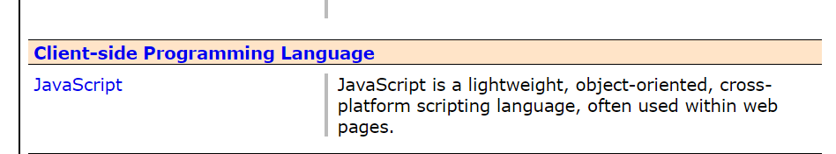According to w3techs.com, which analyzes the site info of websites, these are the technologies used when building this website.

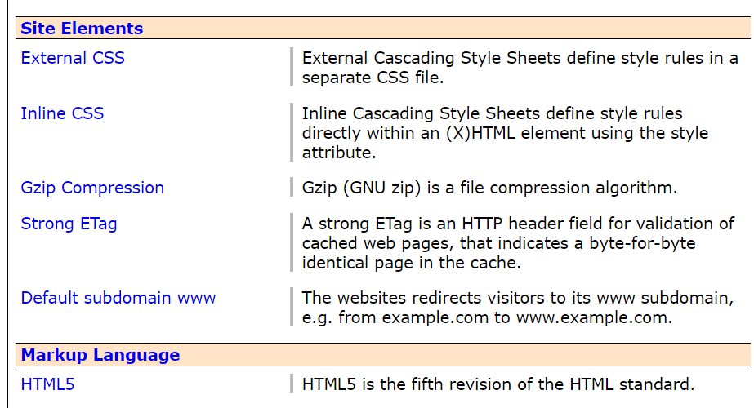

Figure 12.0

**Designing the website**

Home page

The home page is the first page of any website. It has to be designed in a way that captures the attention of the user. Therefore it has to have the most exciting news about the author or author’s works. If the homepage was attractive, the user will be motivated to go through the other pages of the website. The home page will have four sections apart from the header and footer. The header will have the logo of the author’s publishing company, and a horizontal navigation bar. The first section of the home page will have a picture of the author, with her credentials. But there wouldn’t be too much information, just enough to make the user curious. There will be an “Explore” button if the user is curious to know more about the author, which he/she can click to navigate to the page which has more details about the author. This helps to make the website simpler. The second section will have the picture and description of the author’s latest release. This gives the image that the author is actively writing books. The third section will have a video of the author, interacting with her fans. This adds an element of interactivity. The fourth section will have some of reviews that the author has received for her works. They will be selected reviews from the mass of reviews the author has received. The footer will have a small disclaimer from the publishing company and with icons to connect to their socials. This helps to validate the publishing company and gives the user many ways to contact them with.

About

The about page is important for a website as it will give information about the author to the user. It will have a picture of the author and a small description of the author, with a “See More” button which will direct the user to a more detailed biography of the author. They are laid one beside the other. The description is written in such a manner that the user is sufficiently curious enough to click on the “See More” button. This web page is very short, and not crowded with information, and it is upto the point in order to make it simple and user friendly.

News

The news page is important to keep the user up to date with the latest events and stories surrounding the author and her works. This makes the website more interesting and updated with the latest events. This page will have a few posts, which will have “Read More” buttons, which when clicked will direct the user to the relevant news articles. They will be arranged row wise one above the other, and there will be a small picture for each post. The headlines will be written in such a manner that they will capture the user’s attention. The user can choose which post to read in more detail and be directed to the relevant article page. The article pages will be longer and have more pictures in them.

Gallery

The gallery page gives the user an insight into the author’s public life, and it validates the author as an important person. The Gallery page of this site will have photos of the author at important events, arranged like a grid, and with a small caption with the event name and date at which the photo was taken. When the user clicks on a picture, he will be able to see the full picture, and go through the rest of the pictures using a slider.

Shop

This is one of the most important pages of the website. The user is now sufficiently curious about the author and might want to check out her books. Having a shop page makes things more convenient for the user as they can decide on buying books while they are still scrolling the website. The shop page will have the pictures of the books published by the author, with a small description about them and their prize. They will be arranged row-wise one above the other, with three books in each row. When the user clicks on the picture of a book, he/she is directed to the required Amazon page of the book, where he/she can purchase the book.

FAQs

The FAQ section is something seen in most author’s websites. It helps to add an element of interactivity with the author, and encourages readers to ask questions and interact with the author more. It also answers the questions a user might have when visiting the author’s website as they are questions that majority of the people ask the author about. This page will be simple, and will have a section with the questions inside an interactive widget. The question will be visible to the user, and when the user clicks on the details icon, it will expand to show him the answer.

Contact us

The contact us page is one of the most important pages of any website. This page will have a google map to show the location of the publishing company using a google map so that things are made more convenient for the user. There will also be a form for the user to fill in order to contact the company. The other contact details will also be displayed on the page. So there are multiple ways for the user to contact the company if he/she wants to.

Moreover, every page of the website will have the same header and footer. In responsive mode, the horizontal navbar will hide, to display a vertical navbar when the menu icon is clicked.

**Task 02**

**Sitemap**

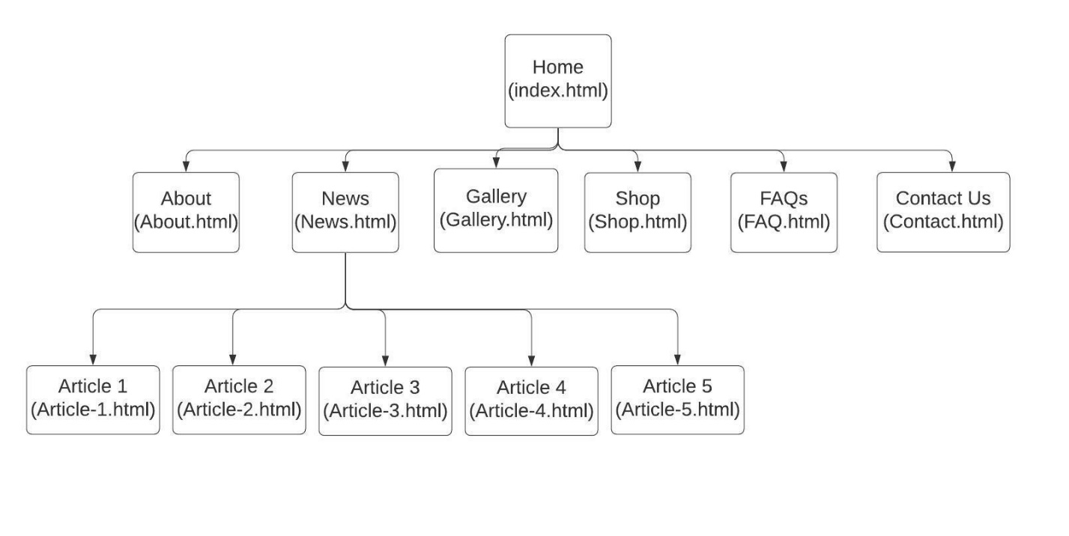

Figure 13.0

This is the sitemap of the website. There are 12 pages in total. The main menu is visible in all the pages. When the user opens the website, the Home page will be visible and the user can go to other pages using the main menu in the Home page. The pages are linked to the Home page as shown above. The News page has 5 articles, and they are linked to the News page in such a manner that the user can access any of the article that he/she wants, when he/she visits the News page.

**Wireframes**

Home page

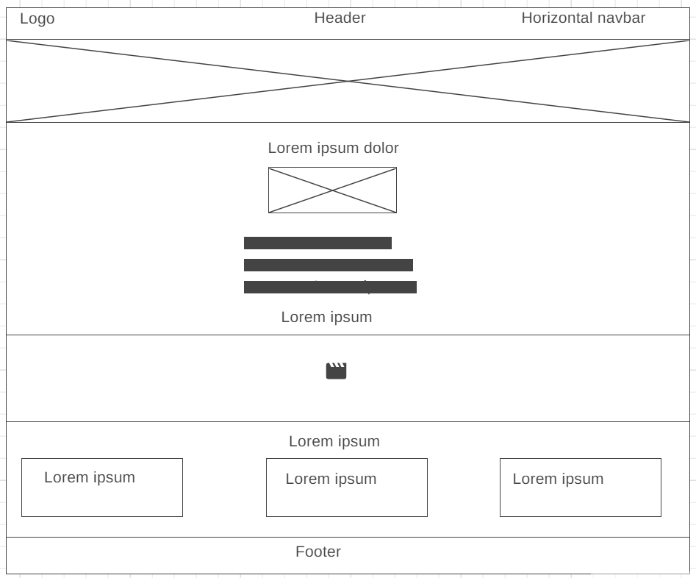

Figure 14.0

This is the web view of the Home page of the website. The logo is placed on the header of the website where it will be prominent for the user to see. The navigation bar is placed at the right of the header. The top section of the website has a background image, which will have the image of the author, as well as a small description, to introduce the author to the user. If the user is curious he/she can click on the button under the description which will give a more detailed description of the author and her works. Below there is information about the author’s latest release. This is done to capture the user’s attention to the author’s books. Next up, a small video of the author herself will be included, so that there will be an element of interactivity included between the user and the author. The third section has a few selected reviews for the author’s works. The footer section will include the custom disclaimer of the Publishing company and links to their socials.

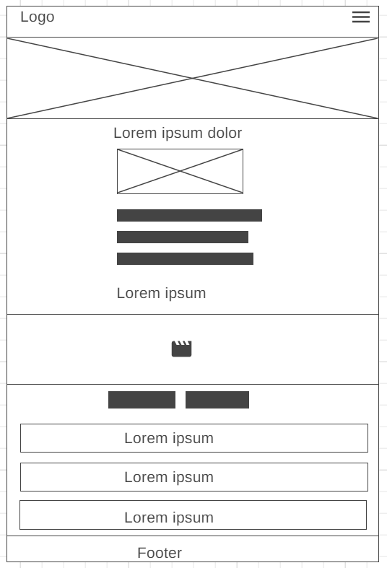

Figure 15.0

This is the homepage of the website when in responsive mode. The images become bigger in a smaller screen. The textboxes that were arranged one beside the other, get arranged column-wise, so that it will be easier for the user to read. The images, videos etc. will be adjusted according to the screen size. The horizontal navigation bar vanishes to be replaced by a menu icon, which when pressed will open up a vertical navigation bar.

About

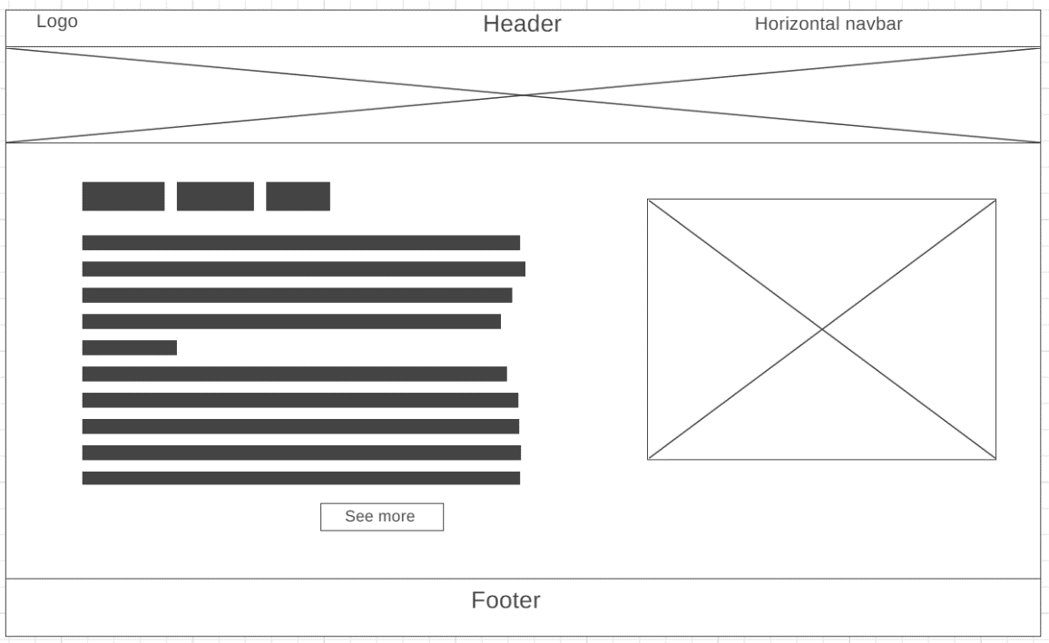

Figure 16.0

This is the desktop view of the About page. The header and the footer will be the same for all the web pages. But the main content will change. In the about page, there is a picture of the author on the right, and a small biography of the author on the left. Too much information is not crowded at once to maximize the user experience. If the user is interested in knowing more, he/she can click the “See more” button, which will direct him/her to a more detailed biography.

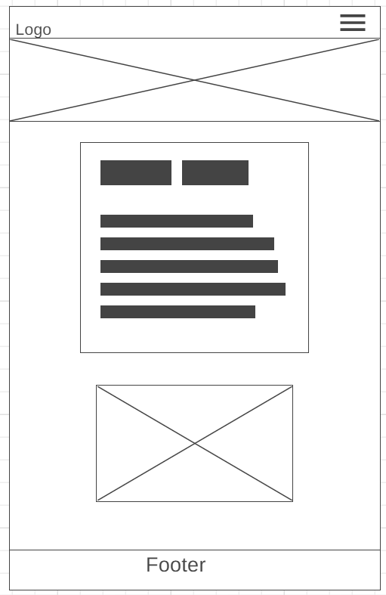

Figure 17.0

This is the view of the “About” page when in responsive mode. The paragraph containing the description comes to the top and the image comes to the bottom. The text and image adjust according to the screen size, and can be seen easily by the user.

Gallery

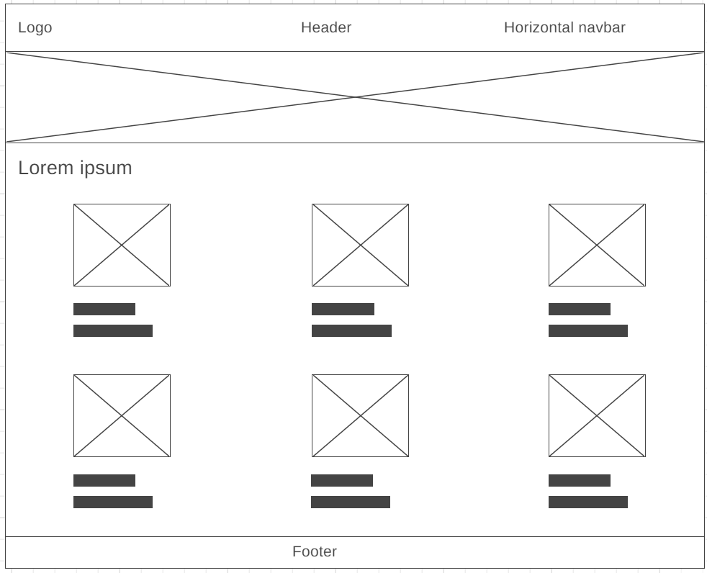

Figure 18.0

This is the desktop view of the “Gallery” page of the website. The pictures are arranged like in a grid. They have a caption each. They are arranged in an orderly manner, ensuring good user experience.

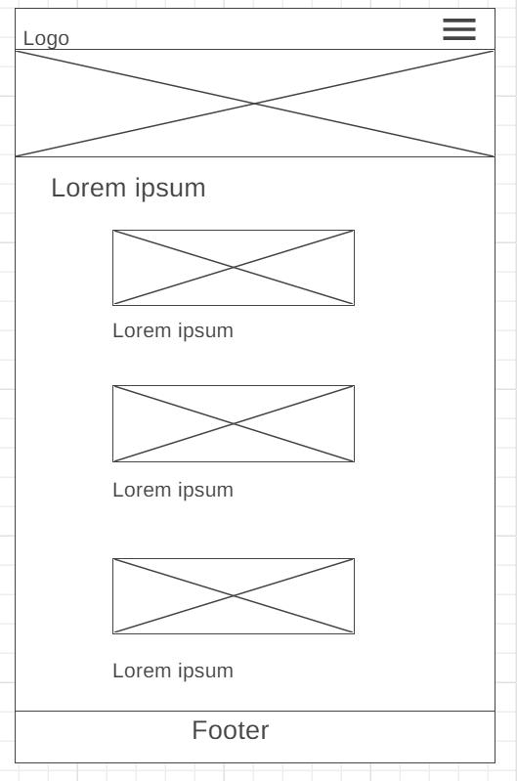

Figure 19.0

This is the mobile view of the “Gallery” page. The images adjust to the size of the screen. The user has a good view of the images and the captions. This maximizes the user experience in the mobile view of the website.

Shop

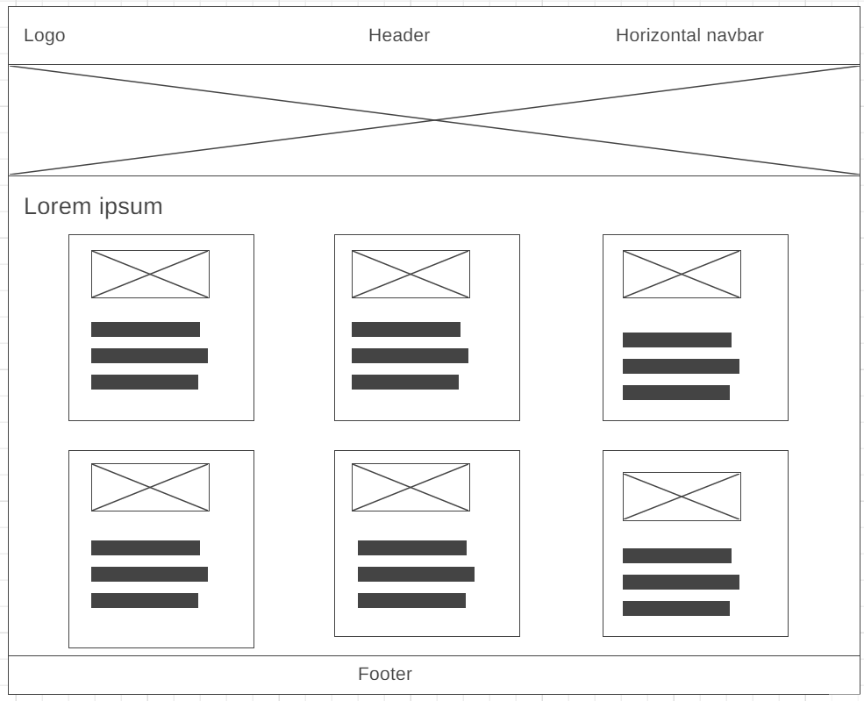

Figure 20.0

This is the desktop view of the “Shop” page of the website. The images of the books along with their description and their price are arranged in the following manner. It is arranged in a way that is clearly visible to the user, and in an orderly manner.

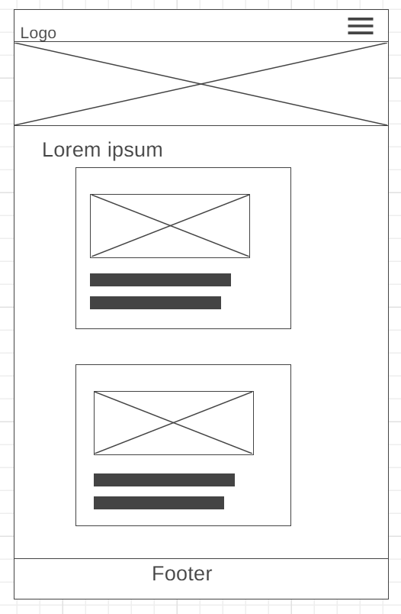

Figure 21.0

This is the mobile view of the “Shop” page of the website. The images and the text adjust themselves according to the screen size so that they are bigger, and more visible to the user. The user has to scroll in order to view the other items.

FAQs page

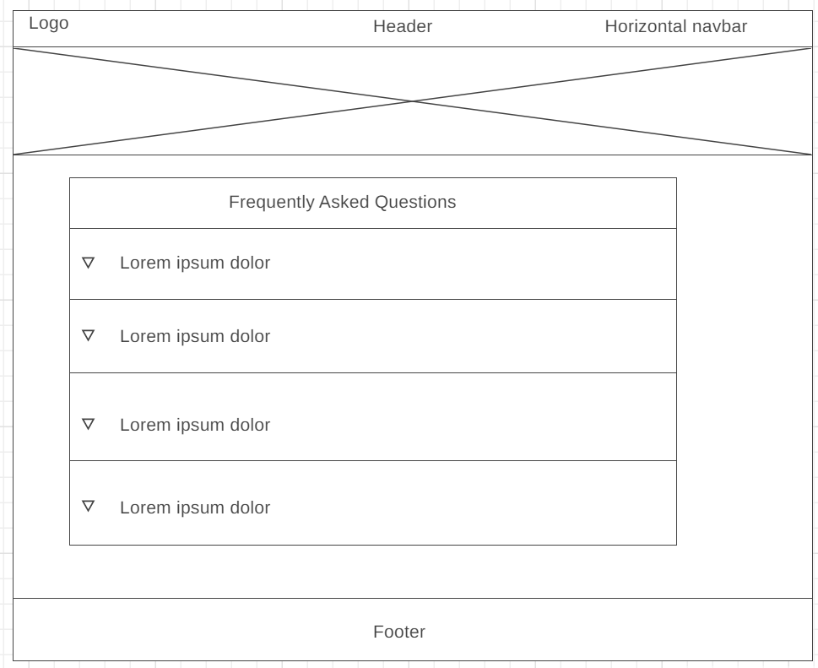

Figure 22.0

This is the desktop view of the FAQs page in the website. This page has the frequently asked questions from the author, and there is a details icon with each question, which is an interactive widget. When the user clicks on the icon, the question expands to show the answer as well. This ensure that the questions and answers are not crowded into the page. The user can select the question he wants to view, and see the answer.

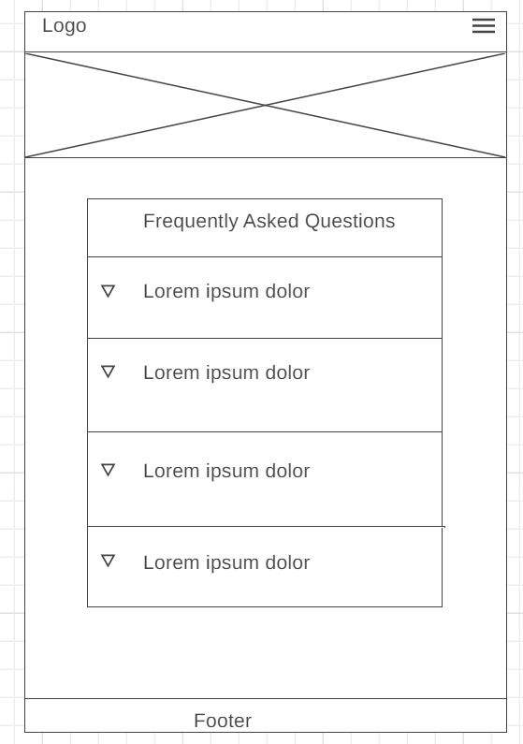

Figure 23.0

This is the mobile view of the FAQs page. The contents of the page adjust according to the screen size. The user is able to see the contents clearly.

Contact us

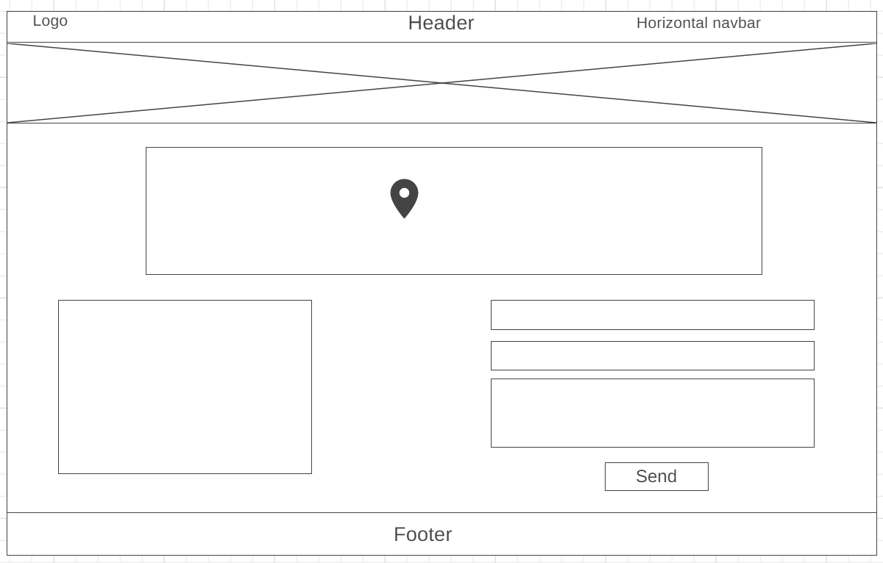

Figure 24.0

This is the desktop view of the “Contact Us” page of the website. The page has a Google Map to show the location of the publishing house clearly. The contact details of the company is given in a side of the web page, and a form with the necessary validations. The page is set up in a way that is extremely convenient for the user to get the contact details as well as the location of the publishing company if they want to contact it.

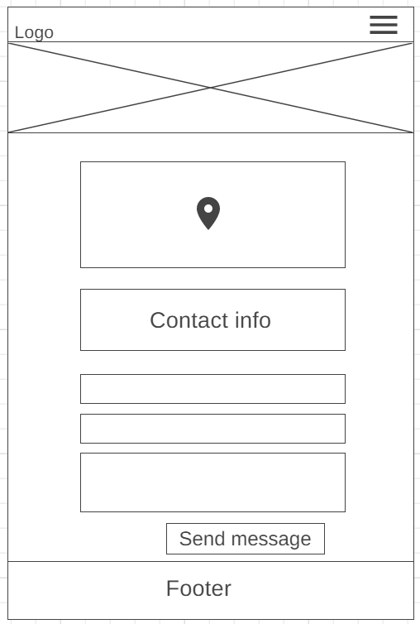

Figure 25.0

This is the mobile view of the “Contact Us” page. The elements of the page arrange themselves one over the other so that the user has a good view of them. The layout is convenient for the user.

News

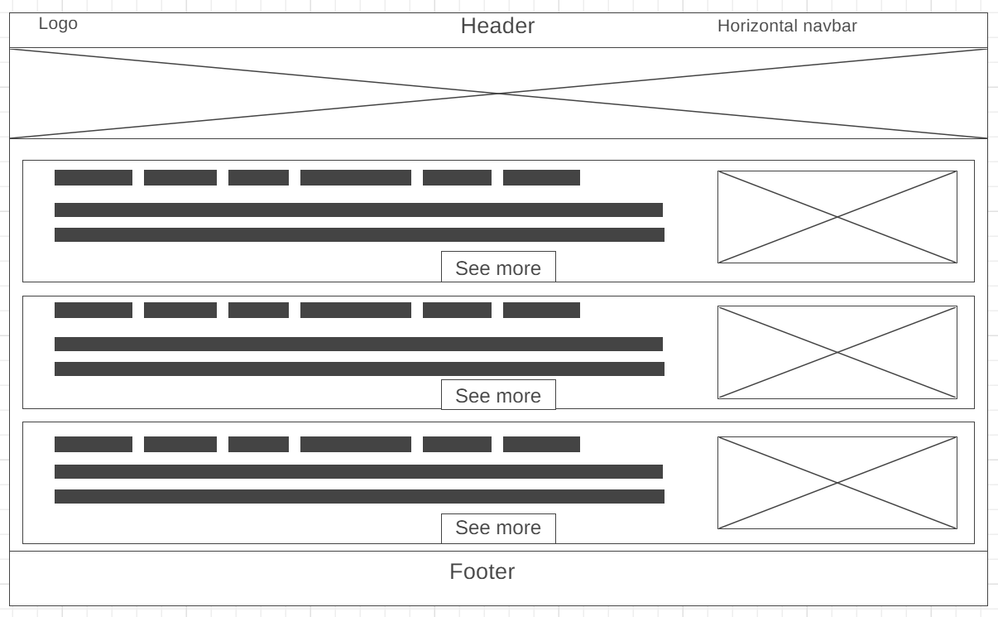

Figure 26.0

The “News” page as viewed on desktop is shown above. It has posts with “See More” buttons which will lead the user to the respective newspaper articles.

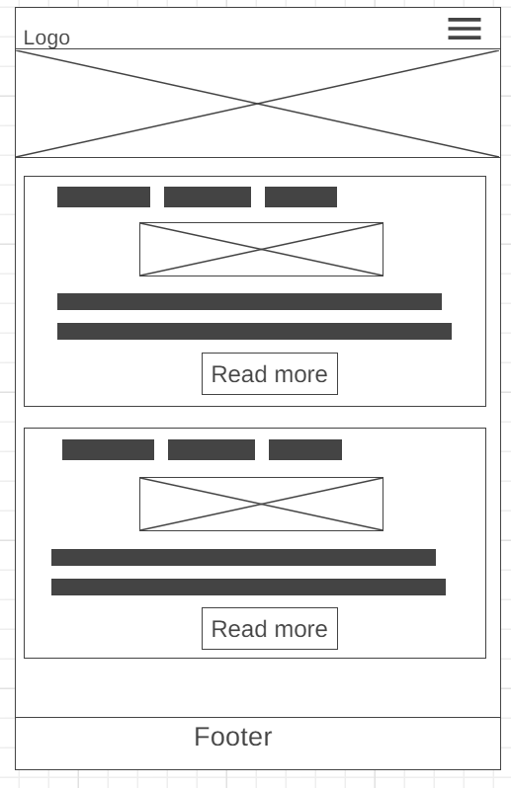

Figure 27.0

The “News” page of the website when it is in responsive mode is shown above. The posts become bigger and the images are more visible to the user. This ensures a good user experience on mobile.

**Task 03**

**The HTML document**

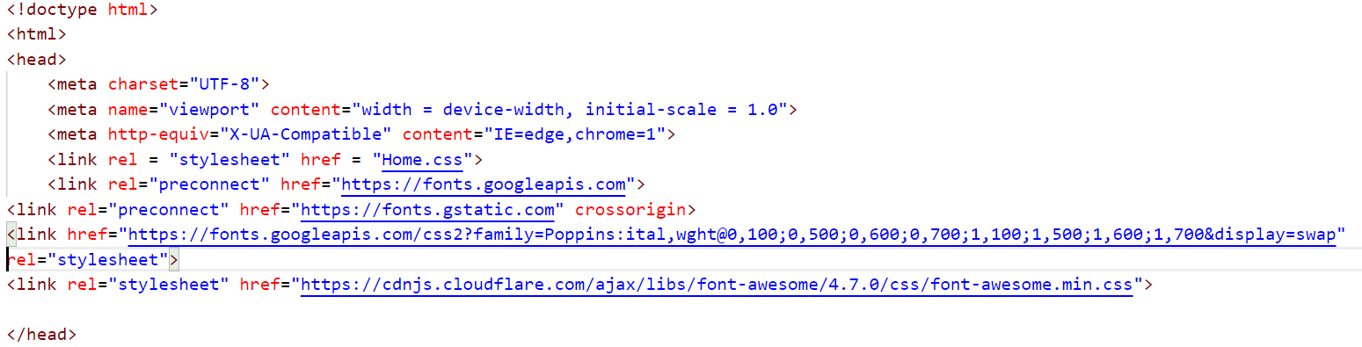

Figure 28.0

This is the beginning of the HTML document of every web page in the website. The meta charset attribute specifies the character encoding for the HTML document. The meta viewport tag helps to make the web pages responsive. The viewport is the user’s visible area of a web page, which changes depending on the screen. Next the external CSS page has been linked to the HTML document. The fonts have also been taken from Google fonts. The link to apply those google fonts to the text in the webpage has also been attached. The next link is for the icons that have been used in the web pages. These icons have been imported to the page using Font Awesome 5 website.

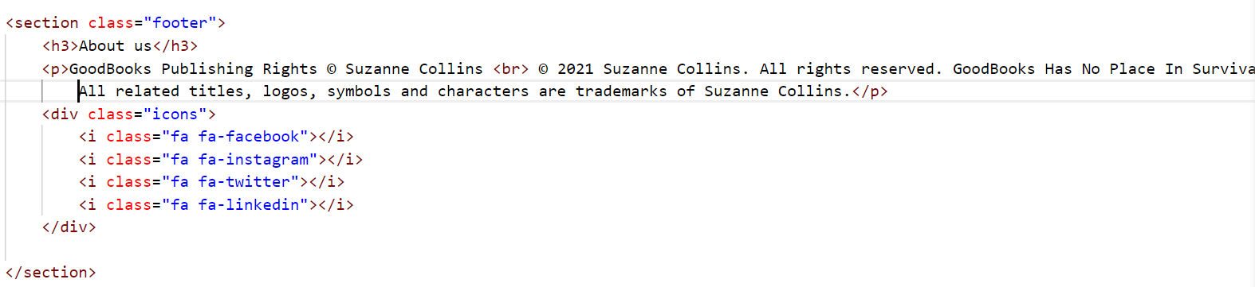

Figure 29.0

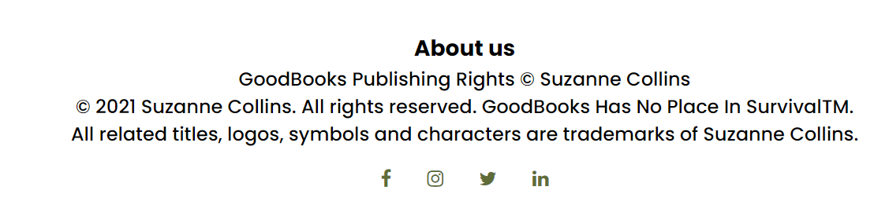

Figure 30.0

These icons have been thus used mainly in the footer and in some other places in the website.

**The header section**



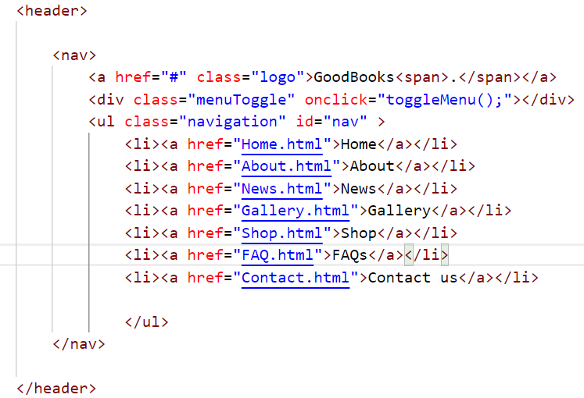

Figure 31.0

This is the html code used in the header section and the horizontal navigation bar in the header section, with its animation effects. In the html code, the contents of the navigation bar have been listed using the <li> tags. The li tags have <a href> tags so that they are transformed into hyperlinks that will lead the user to the relevant page of the website. The classes of the html elements have been defined and they are styled in CSS.

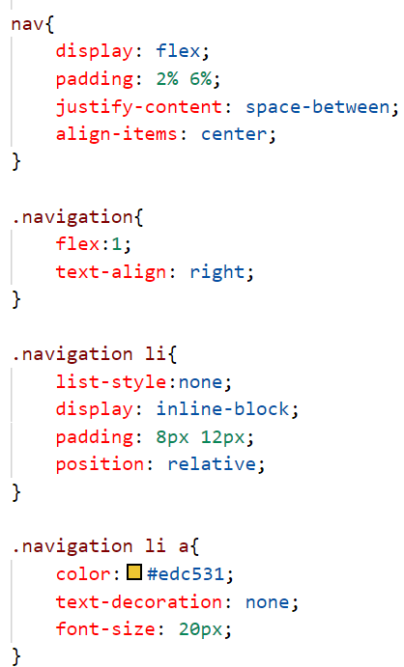

Figure 32.0

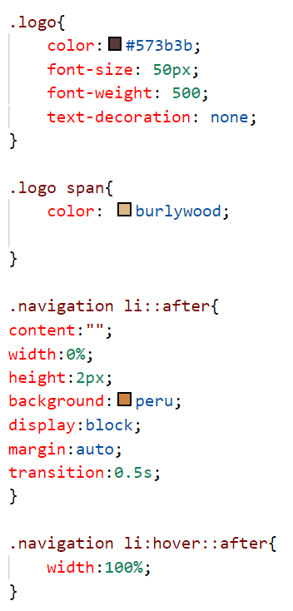

Figure 33.0

The nav element has been defined as a flex container by the code display:flex. This helps to put the logo and the li tags side by side. The padding and justify-content values helps to put some space between the logo and the li tags. align-items: center helps to put those elements in the center of the header. The flex:1 property in the .navigation class makes the flex item flexible and sets the flex basis to 0, resulting in the item receiving the specified proportion of the free space in the flex container. Next, the li tags in the .navigation class have been styled. List-type: none helps to take off the bullet points that appear when listing the elements. Display: inline-block makes the li tags appear one after the other in a single row. The padding values have been added so that there will be sufficient space around the li tags. The position has been set to relative which means the elements are positioned relative to their normal positions. Next the properties like color, font-size, font-weight etc. have been determined for the li tags and the logo, so that they will look pleasing to the user’s eyes, and according to the color theme of the website. Lastly the hover effect for the li tags has been coded. The ::after selector is used to insert something after the selected element. Here the selected element are the li tags. Using that selector a small line of width 0 has been defined, so that the line is there, but it will not be visible. Next the :hover selector has been used for that element and the width has been set to 100%, so that the line appears with a hover effect when the user points the mouse atop the li tags. Thus the horizontal navbar and the logo have been styled.

**The vertical navbar**



Figure 34.0



Figure 35.0

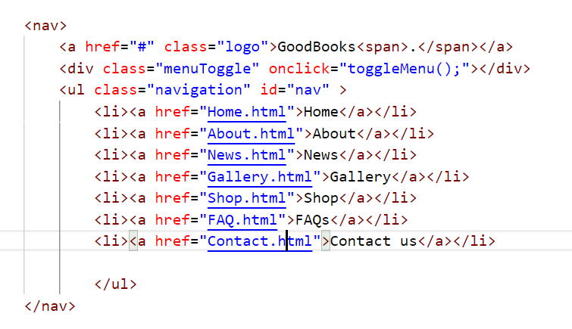

Figure 36.0

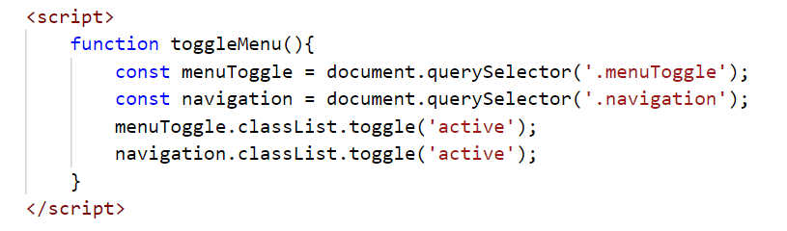

Figure 37.0

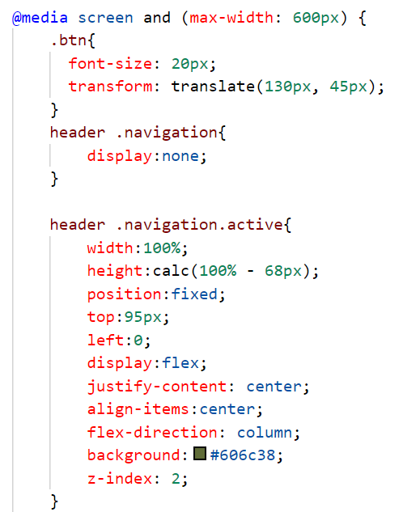

Figure 38.0

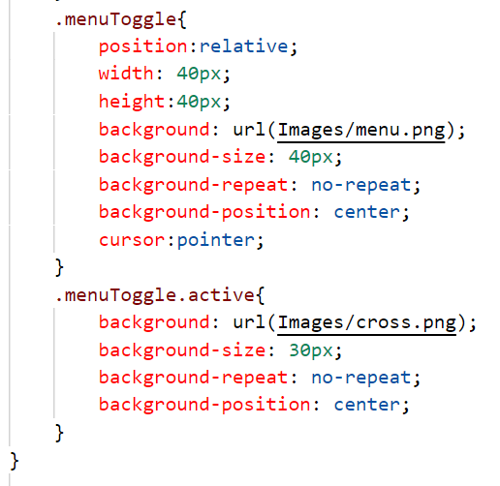

Figure 39.0

However, when in responsive mode/mobile view the navbar cannot be horizontal as that will not give a nice view to the webpage. Therefore a vertical navbar has been built which will appear when the menu icon is clicked. Using the media query, when the screen size is 600px, the display property of the .navigation class has been set to none, so that the usual li tags are not visible when the screen is 600px and less. Next javascript has been added to the code. Above the ul tag there is a div tag whose class is “menuToggle”. This class has been selected by the queryselector in JavaScript and a class “active” is added to that class using classList. Then the onclick function has been defined in the html div tag so that whenever that div tag is clicked, the “active” class is added to the menuToggle class. Then .menuToggle .active has been styled in CSS so that whenever the menu icon is clicked, it toggles to give the close icon. Next the .navigation class which has the li tags has also been selected by javascript using the queryselector, and the same class “active” has been added to it using classList. This enables the user to click on the menu icon and view the navbar.

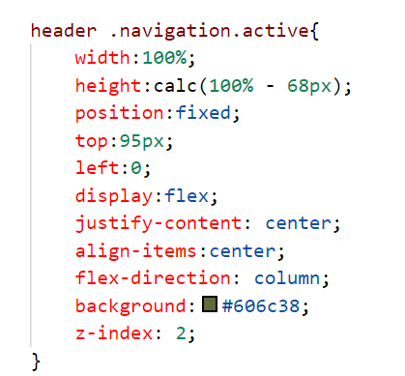

Figure 40.0

Using these properties for that class the li tags are made visible in a column-wise manner. The z-index helps to put the vertical navbar element on top of the other div elements on the webpage. Thus the vertical navbar has been built using html, CSS and JavaScript.

**Buttons**



Figure 41.0

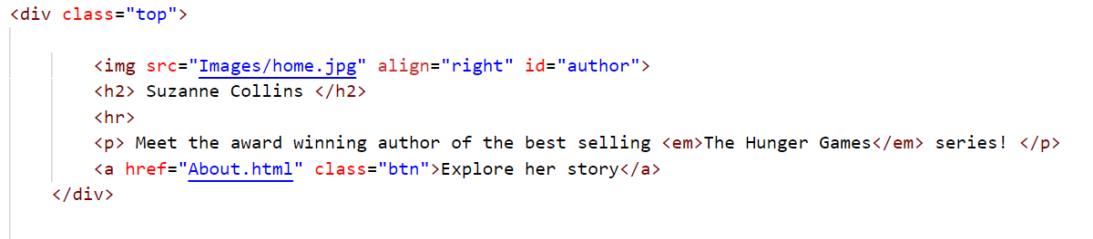

Figure 42.0

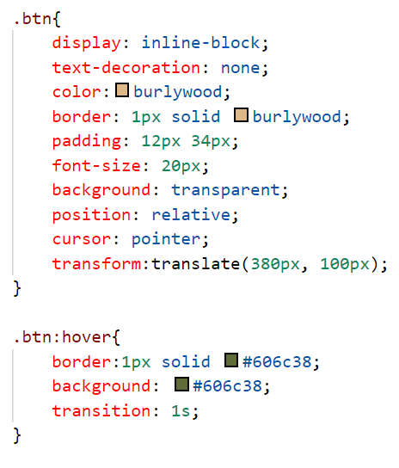

Figure 43.0

There is a button on the homepage. When the mouse pointer is placed on top of it, the button turns green. This button is a hyperlink which is built in the html code and it has been styled like a button using CSS, by using properties such as border, padding etc. The hover effect has been has been applied to the button using the CSS hover selector, so that whenever the pointer moves atop the hyperlink, the button turns to a green color. The transition property used in the .btn:hover class helps to change the property values smoothly over a given time.

The same CSS code has been applied to all the buttons that appear throughout the website.







Figure 44.0

**Embedding the YouTube video**



Figure 45.0

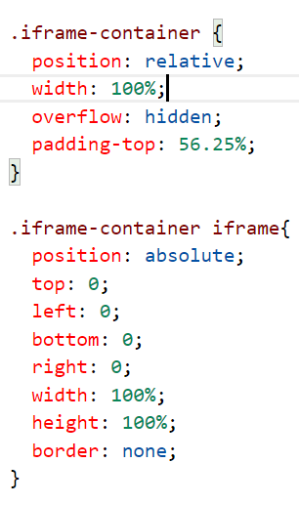

Figure 46.0

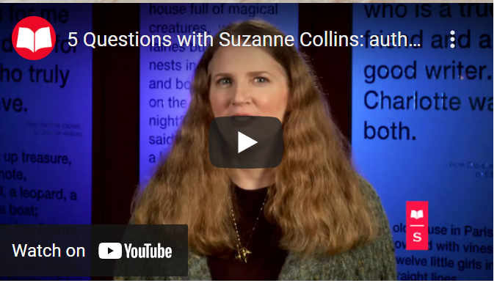

Figure 47.0

A youtube video of the author has been embedded to the page using the <iframe> tag in the HTML code and it has been styled using CSS, so that the youtube video fits the entire screen and the iframe element is responsive. Making the width and the height of the iframe to be values in % helps to make the video responsive.

**Review section**

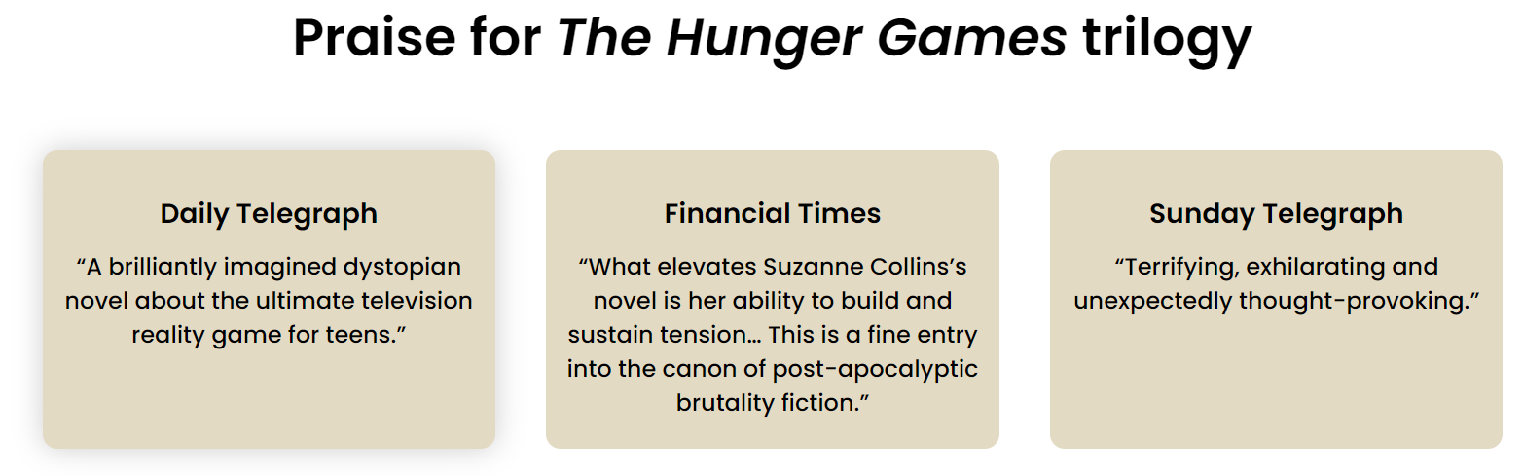

Figure 48.0

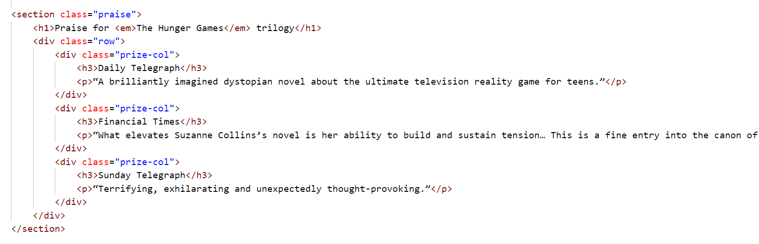

Figure 49.0

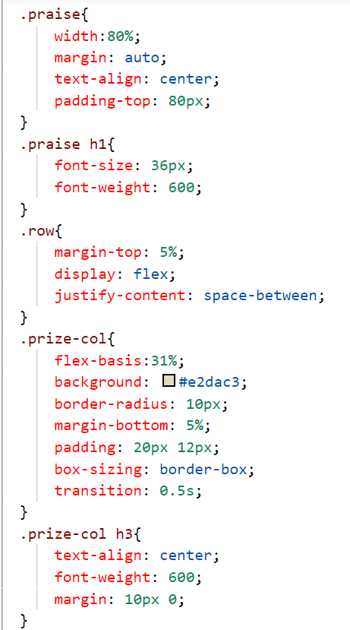

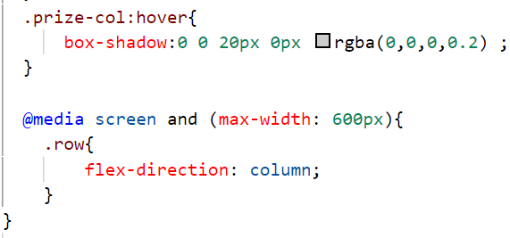

Figure 50.0

**Gallery**

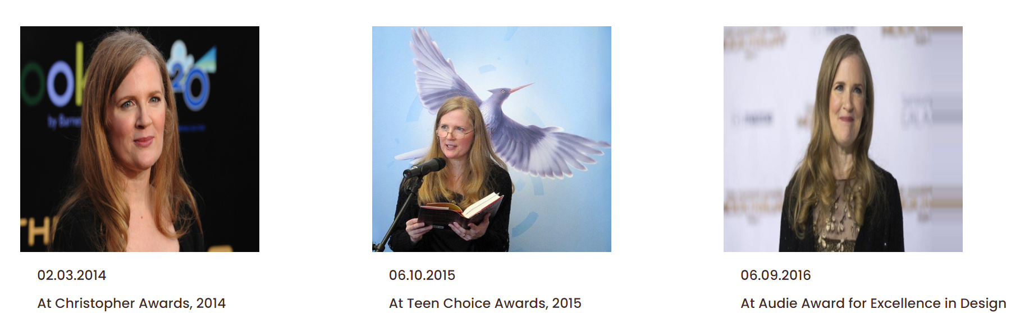

Figure 51.0

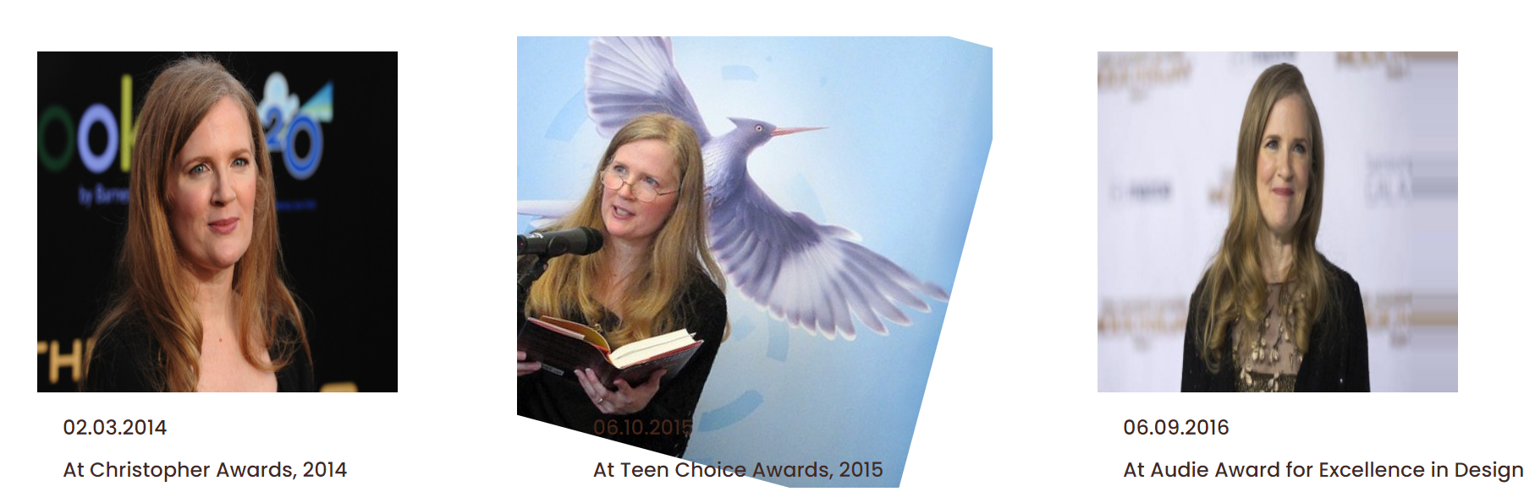

Figure 52.0

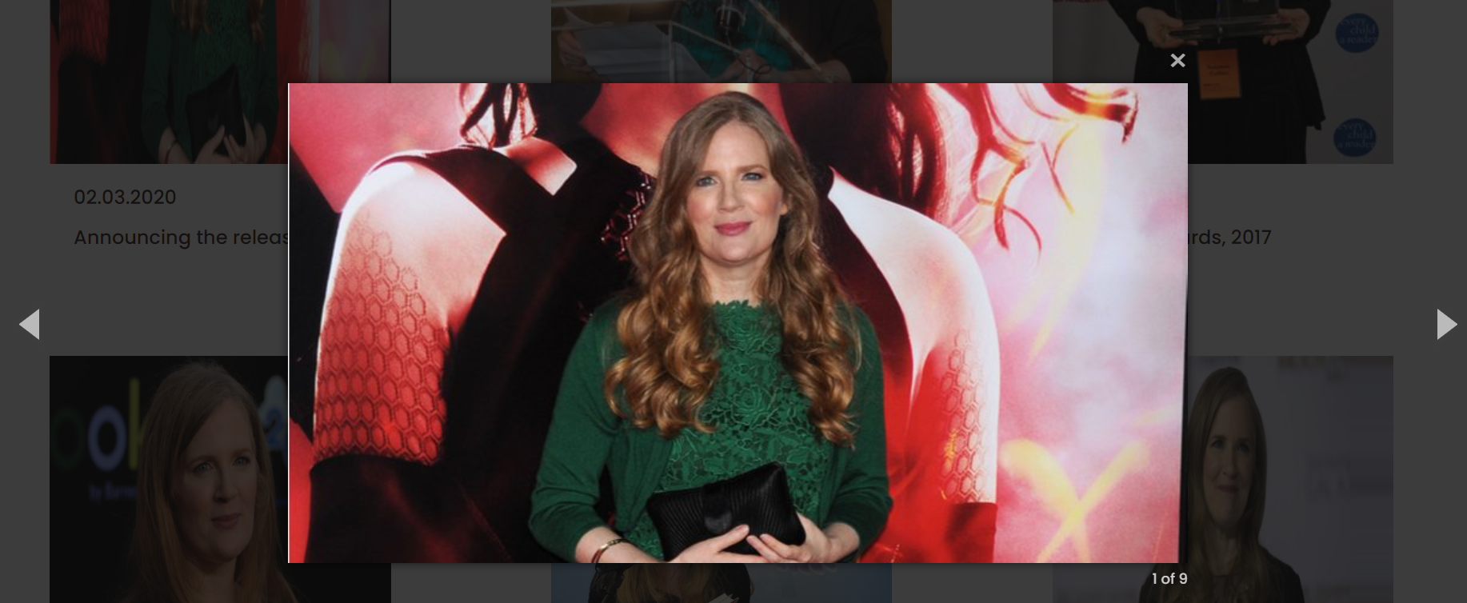

Figure 53.0

In the “Gallery” page of the website, the photos are arranged one beside the other in rows. When the pointer hovers over them, the images become bigger and get slanted sideways. There is a slight animation used for the images. Moreover, when an image is clicked, the full image can be seen, with two icons that enable viewing the next and the previous picture. The pictures are in a slider, therefore they can be viewed one by one whenever the “next” icon is clicked. When the close icon is clicked, the picture is closed and the user is back in the “Gallery” page.

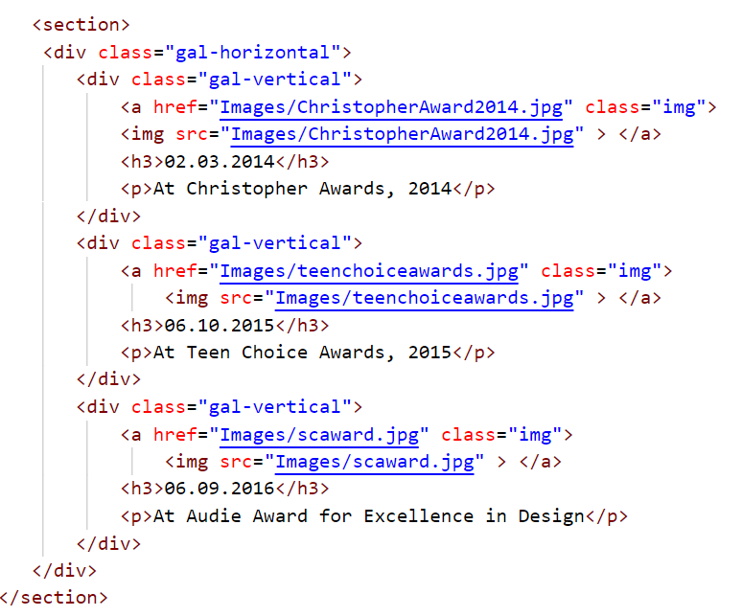

Figure 54.0

This is the HTML of the Gallery page. Images are placed inside div tags, where they are captioned. The <img> tags are hyperlinks as they are placed inside <a> tags. This is done so that the images can be viewed in full when they are clicked.

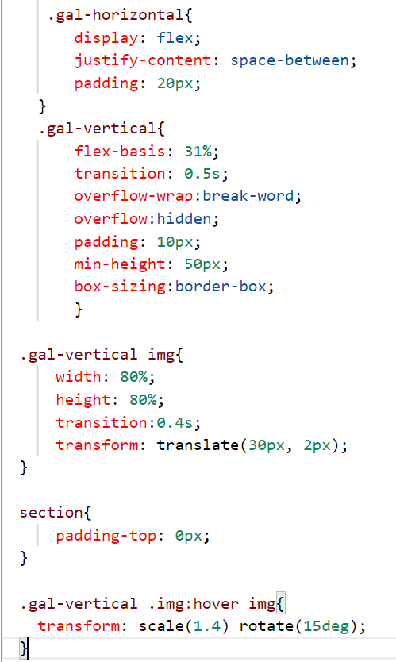

Figure 55.0

This is the CSS used to manipulate the images. The images in the div tag have been placed inside a flex container, and the flex-basis property helps to place the images vertically next to each other in a row. The overflow-wrap: break-word and overflow:hidden help to keep the images and the captions inside the container without overflowing. The hover selector has been used for the images in the Gallery, so that it selects the image when the pointer moves on top of it. Then the transform property helps to rotate the image by 15 degrees. The scale property helps to magnify the image a little when the image is selected.



Figure 56.0

In order to put the images in a slider, jQuery has been used. This has been used by using a jQuery CDN. The link to a jQuery library has been hosted in the head section of the HTML code in order to enable using this library.

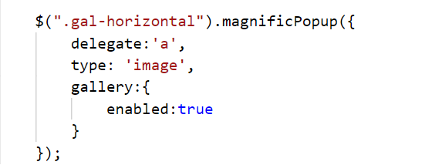

Figure 57.0

Next this javascript code has been used to enable the magnificPopup library which helps to put the images in a slider and go through them in an order.

**FAQ page**

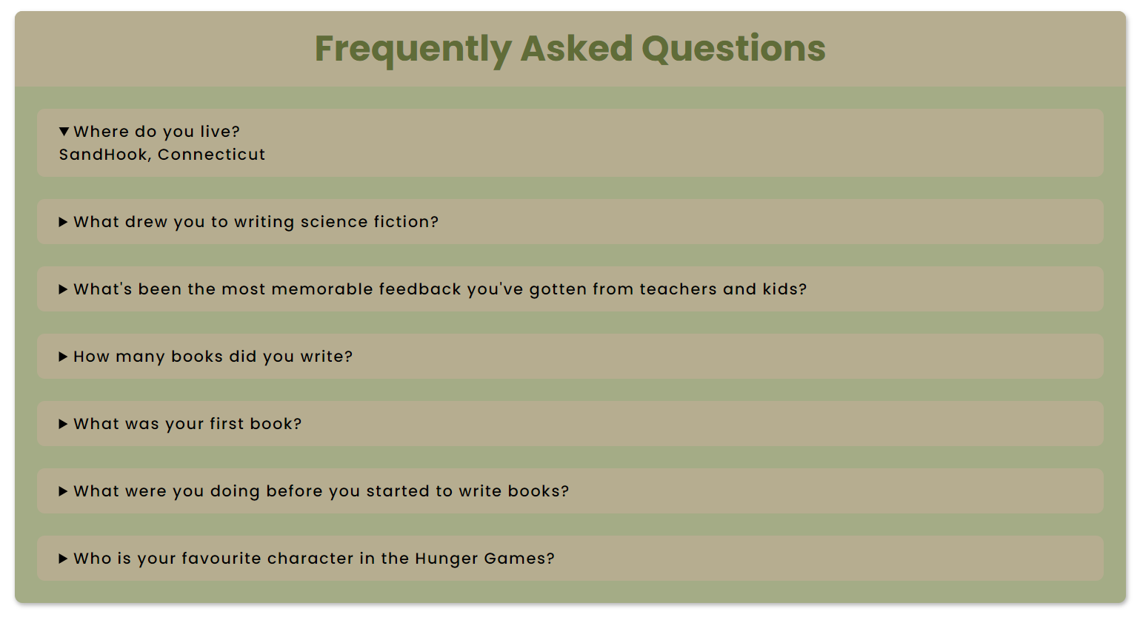

Figure 58.0

This is the FAQ section in the FAQs page in the website.

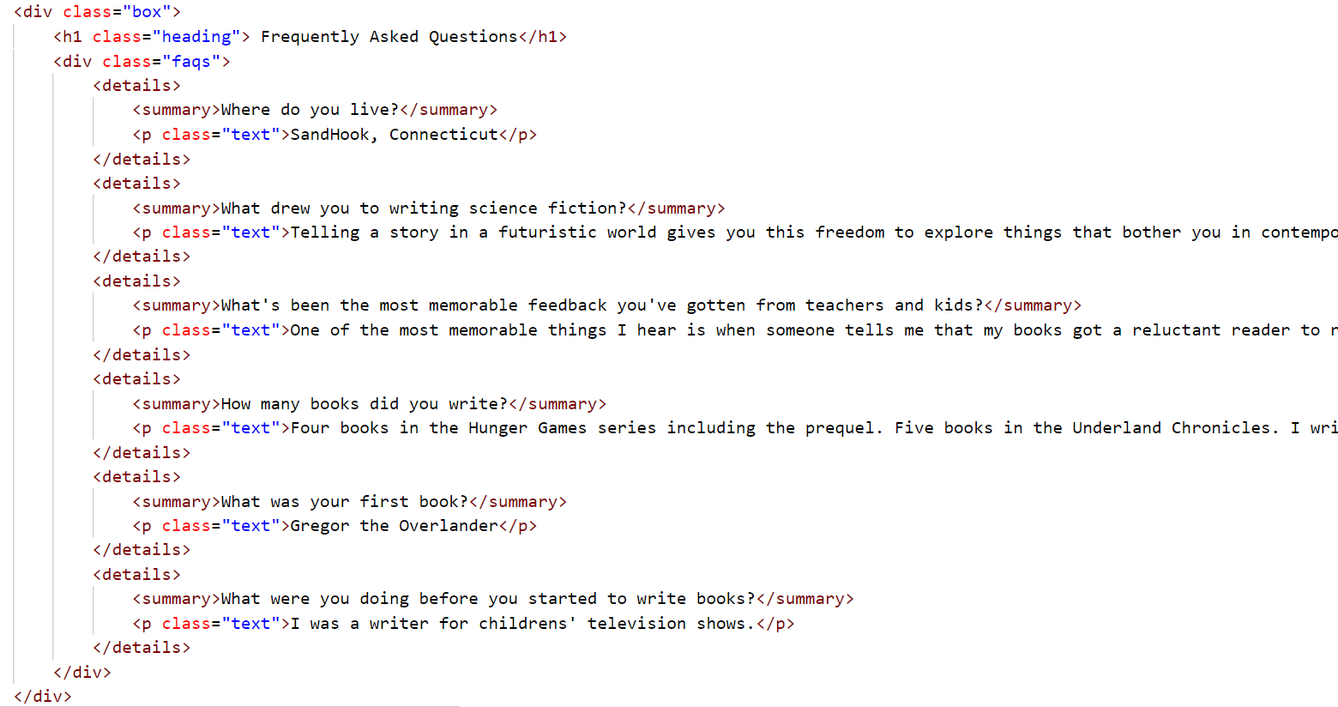

Figure 59.0

This is the HTML code that builds the body of the FAQ section. The <details> tag helps to create an interactive widget whereby the user can open and close it, after viewing the content inside. The <summary> tag defines a visible heading for the <details> tag. It is the first-child of the <details> tag.

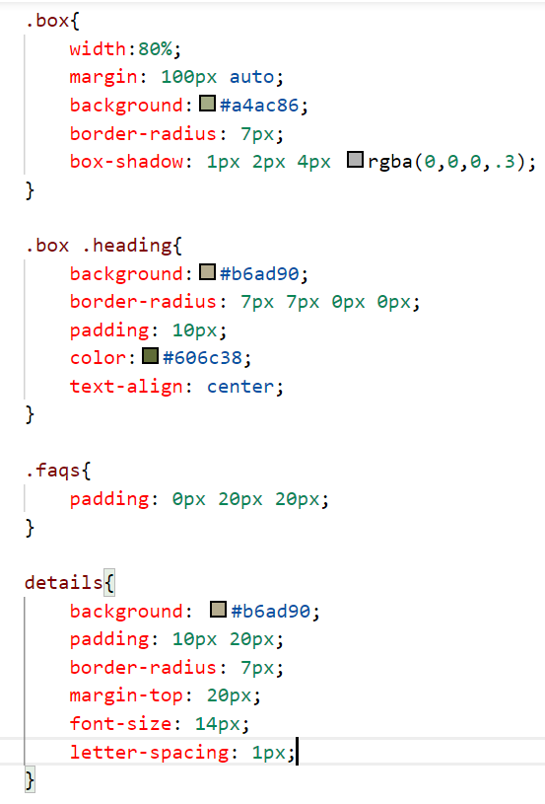

Figure 60.0

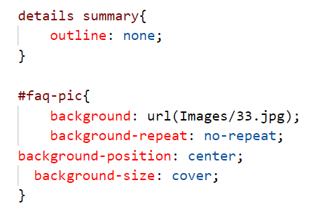

Figure 61.0

Thereafter the div tags have been styled using CSS. The necessary designs such as width, height, padding, color etc have been set. The border-radius property helps to add rounded corners for the main <div> tag whose class is “box”. The box-shadow property helps to add a slight shadow to the .box class.

**Contact Us page form**

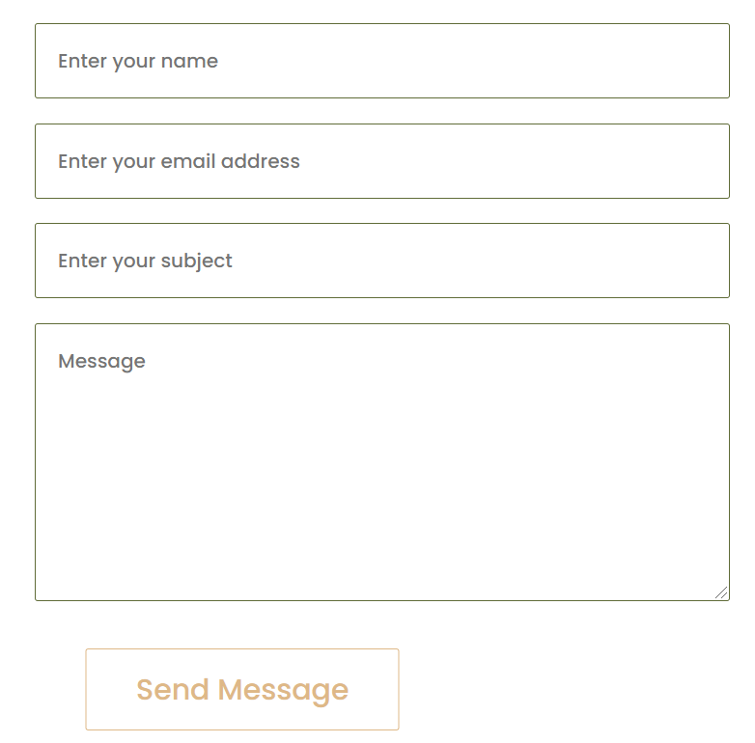

Figure 62.0

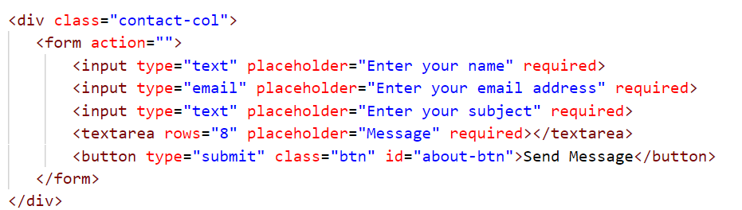

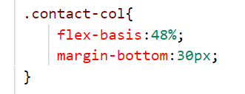

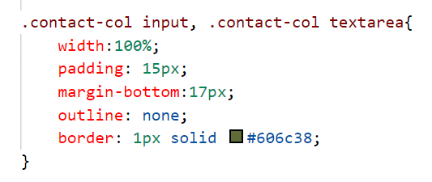

Figure 63.0

The “Contact Us” page has a form which has been validated using HTML and styled using CSS. The placeholder property helps to specify a short hint for the input type that describes the expected value of an input field. The “required” key word helps to validate the textboxes of the form, so that it specifies the input fields must be filled before submitting the form. The <textarea> tag is used to have a text input field with multiple lines inside the text box. The <input> tag specifies the type of input value that must be inserted into the textboxes. The color, width, margin properties for the div tag and the elements in the form are set using CSS.

**Task 05**

Checking for HTML Validation

HTML validation is a quality assurance program which helps to identify the syntax errors in the HTML markup elements of a website. This is extremely important because syntax errors such as open tags, extra spaces can cause a website to look drastically different or render to one browser but not in another. Therefore this is an important step to ensure the technical quality of web pages and reduce poor traffic due to poor formatting and readability (WhatIs.com, n.d.).

The HTML Validator used to check this particular website is Nu HTML Checker([Ready to check - Nu Html Checker (w3.org)](https://validator.w3.org/nu/)). This helps to identify the unintended mistakes in the HTML, CSS and SVG of a document. Using this service, the errors of all the pages of the website ([Suzanne Collins Books (000webhostapp.com)](https://wadassignment-49-32.000webhostapp.com/index.html)) has been checked and the errors have been corrected to display good webpages. The screenshots below were taken after the errors were corrected for each page in the website (validator.github.io, n.d.).

**Home page**

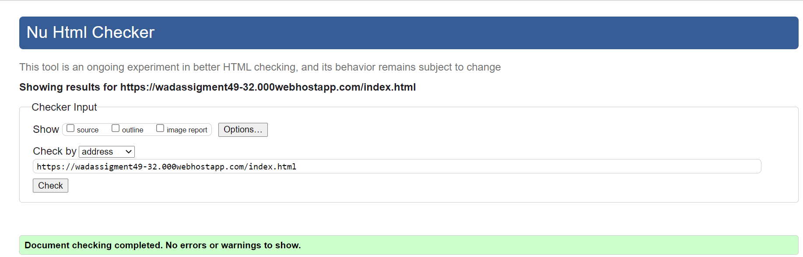

Figure 64.0

**About page**

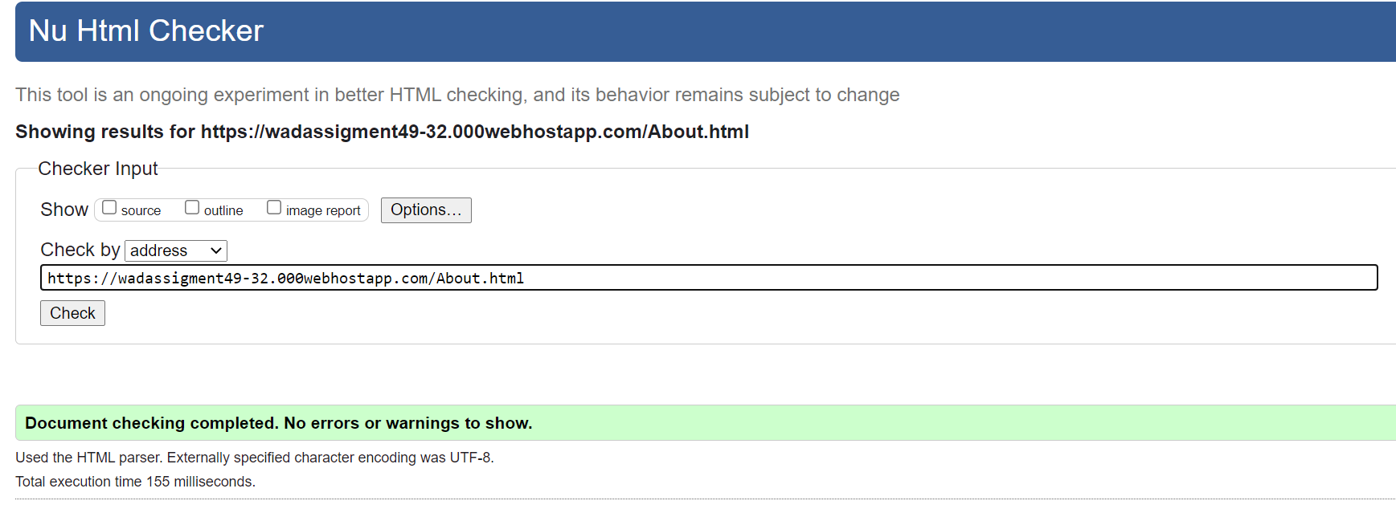

Figure 65.0

**News Page**

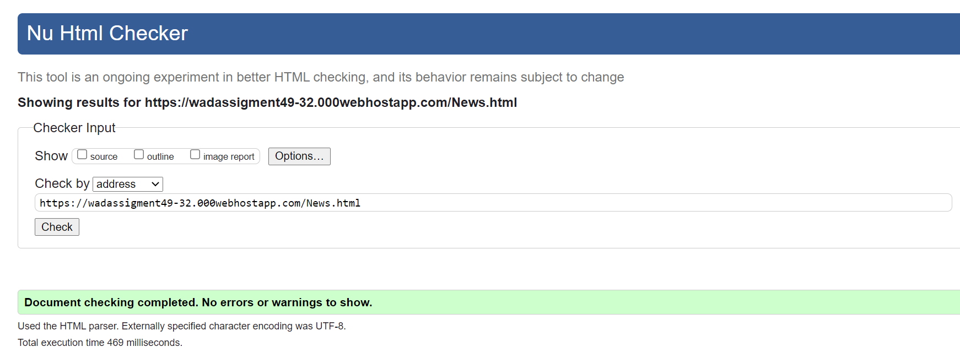

Figure 66.0

**Gallery Page**

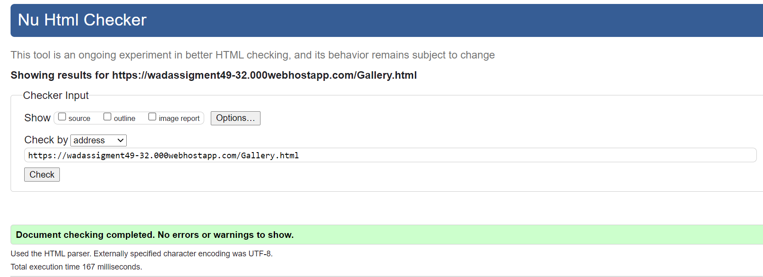

Figure 67.0

**Shop Page**

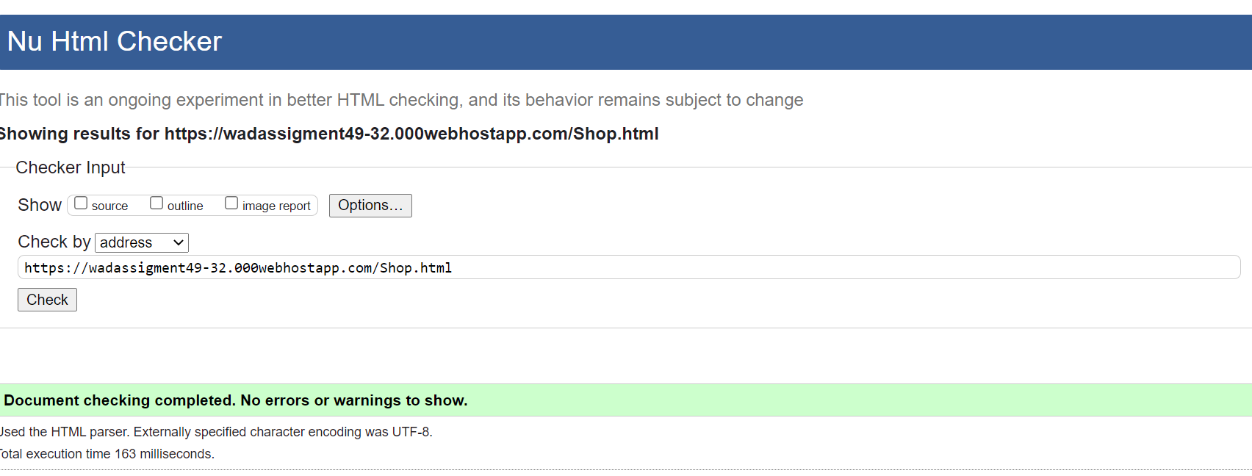

Figure 68.0

**FAQs page**

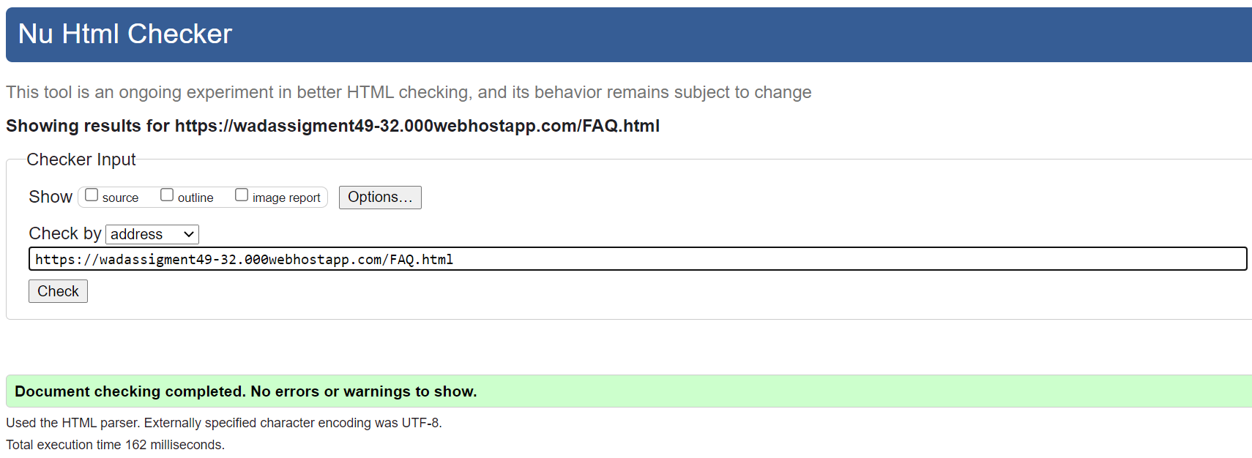

Figure 69.0

**Contact page**

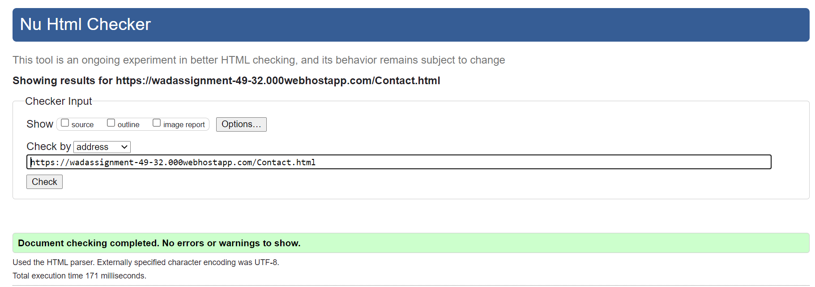

Figure 70.0

**Article 1**

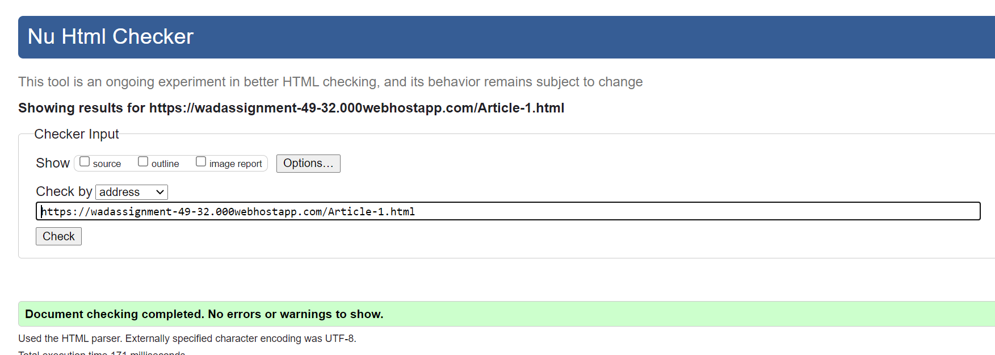

Figure 71.0

**Article 2**

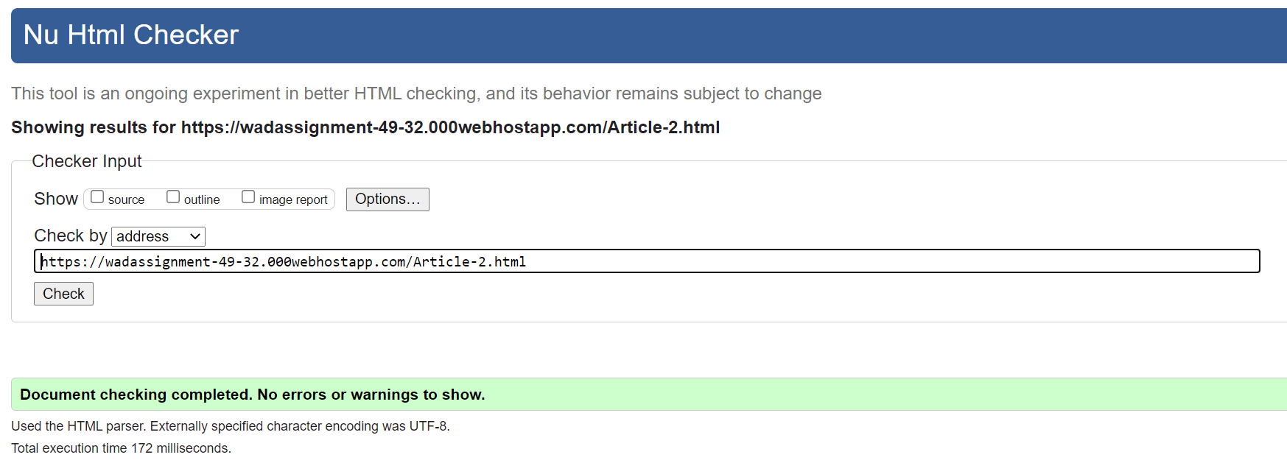

Figure 72.0

**Article 3**

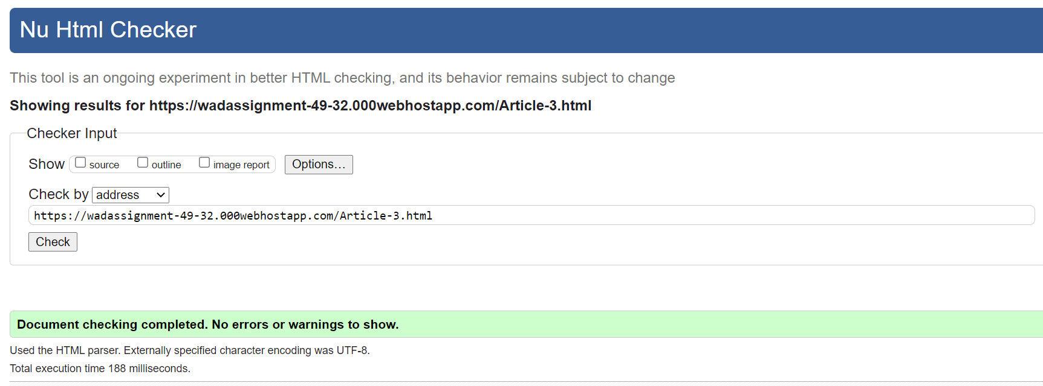

Figure 73.0

**Article 4**

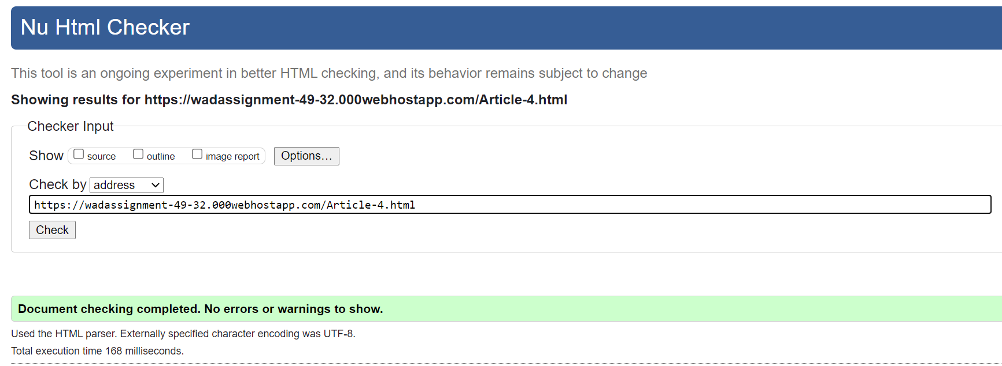

Figure 74.0

**Article 5**

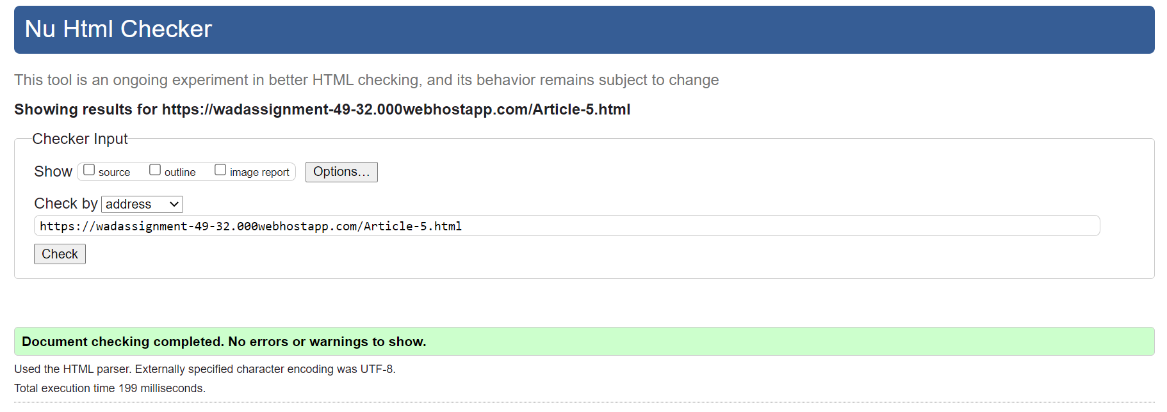

Figure 75.0

Link checker

A link checker is a program that checks a website for the incoming, outgoing, defective links and output it in a report format. This is important for page-optimization for SEO purposes, because if there are a lot of broken links it may seem to the search engine that the website is not properly maintained.

For the purpose of checking our website, W3C Link checker (https://validator.w3.org/checklink) has been used. It is one of the best free tools available, and when the url of the website is given to it, it will check the links and anchors in the web pages. The below screenshots show that the home page and the news page which contain the most links have been checked. The links within the website are working perfectly, while certain links that are connected to the internet are appearing to be broken. However, there aren’t any issues to fix.

**Home**

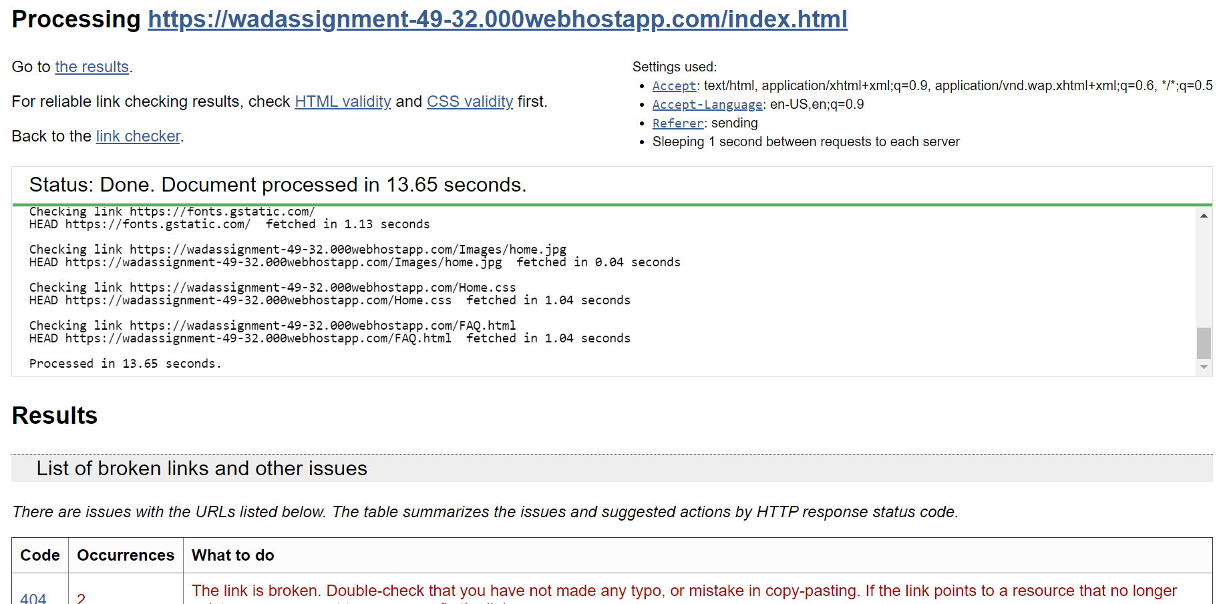

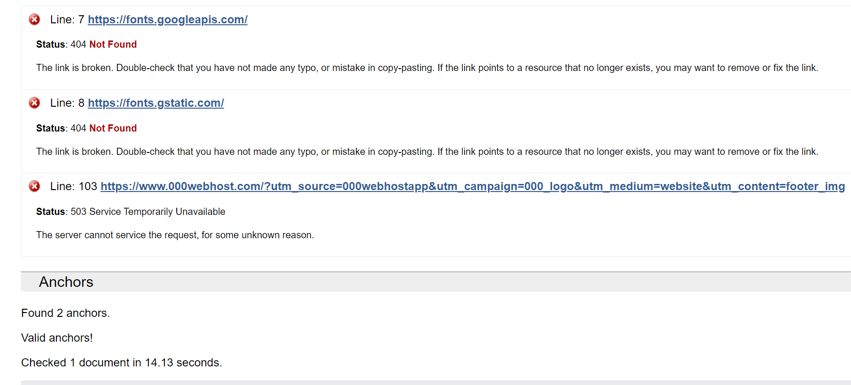

Figure 76.0

**News**

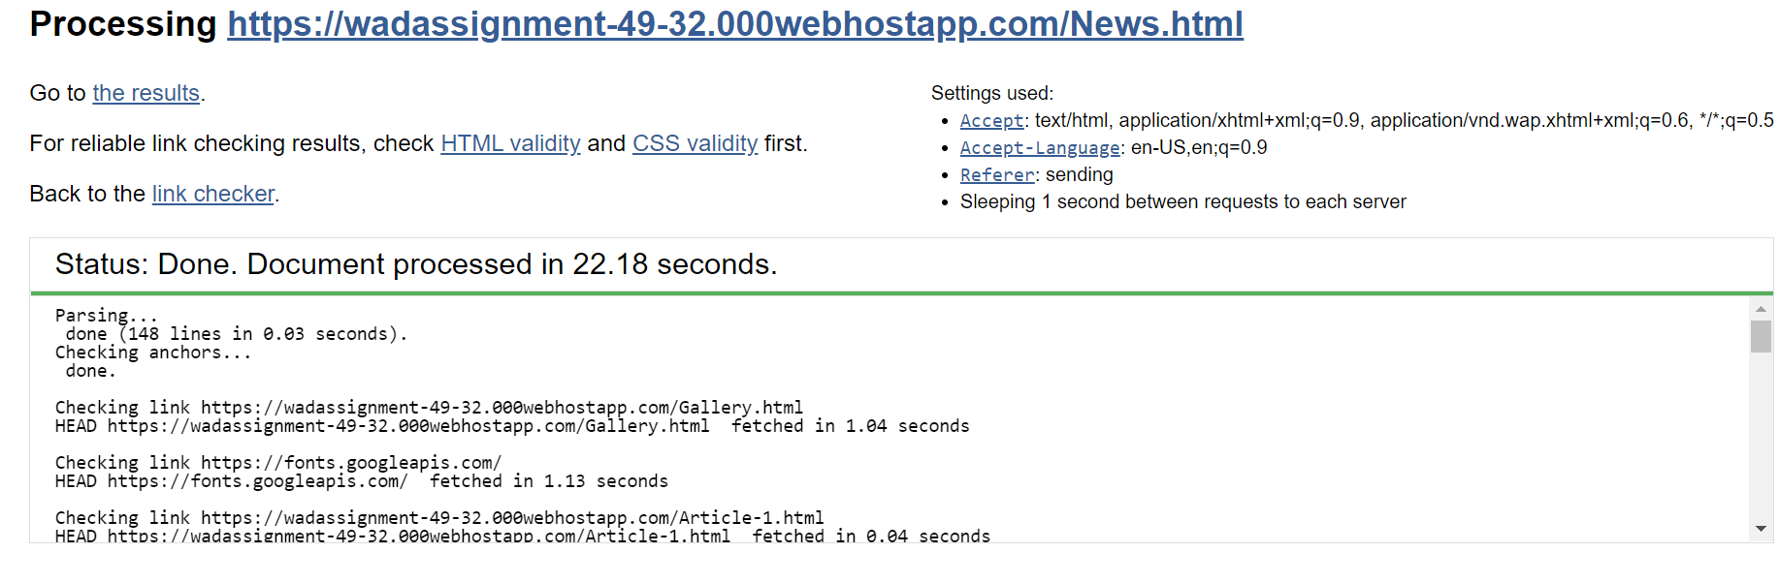

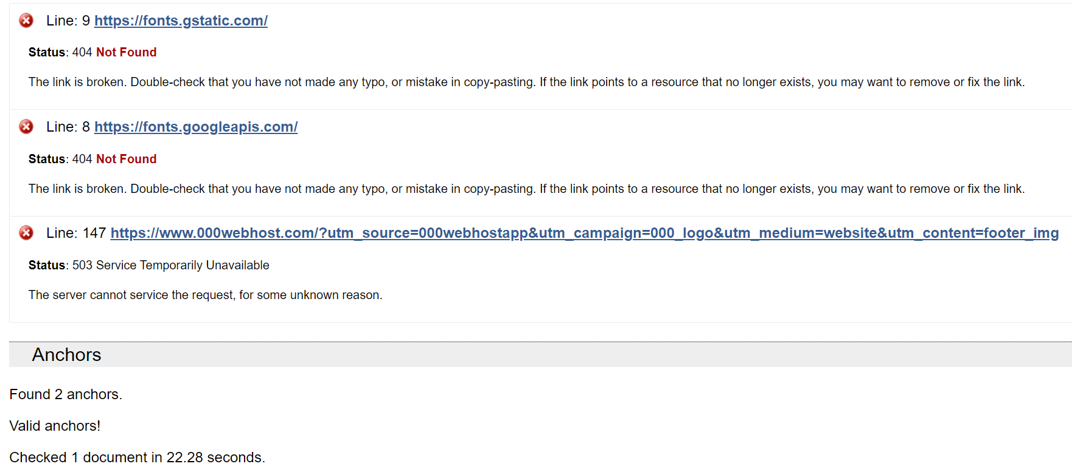

Figure 77.0

Browser-compatibility testing

Testing a website for browser compatibility ensures that no customer is left behind when using the website. Although popular websites like Chrome and Firefox dominate the marketplace, there might be customers using other browsers, and cross-browser testing helps to ensure they are able to access the website too.

Browser compatibility testing has been performed for this site using the website Powermapper.com. (https://www.powermapper.com/products/sortsite/checks/browser-compatibility/) It checks the compatibility of this website in the following browsers:

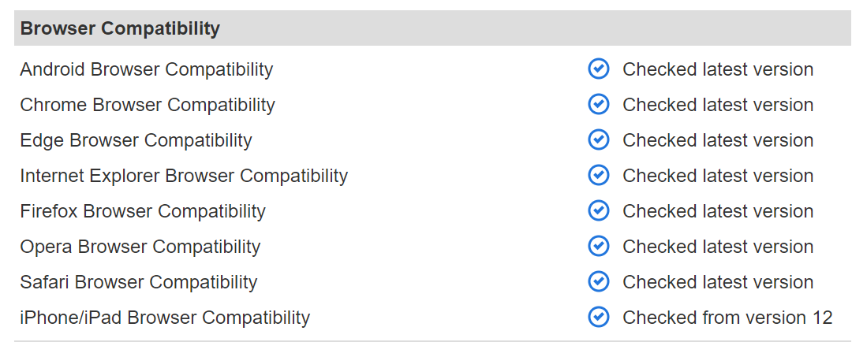

Figure 78.0

The results for the website taken from Powermapper are as follows.

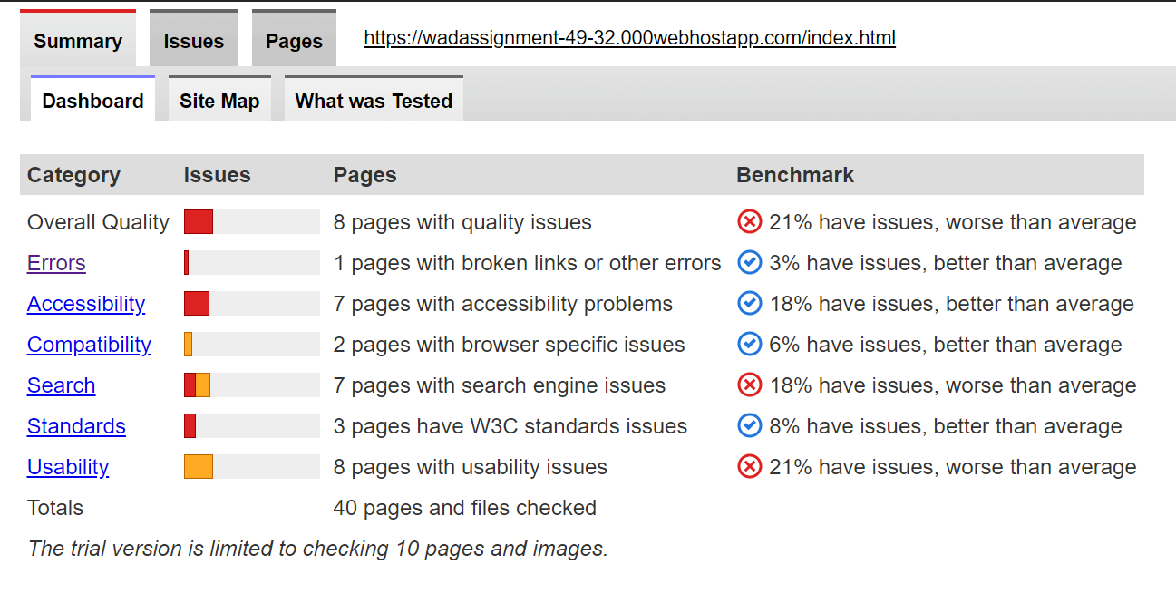

Figure 79.0

Website Speed Test

The speed of a website is very important as it helps in determining the performance of a website. If the speed is too slow and takes too much time to load, it will not appeal to users and will drive them away. Therefore the web pages of the website have to be optimized in such a way that they load in the fastest possible time. The speed of this website has been checked by the free online tool Pingdom.com (<https://tools.pingdom.com/>) and the results are as shown below.

**Home**

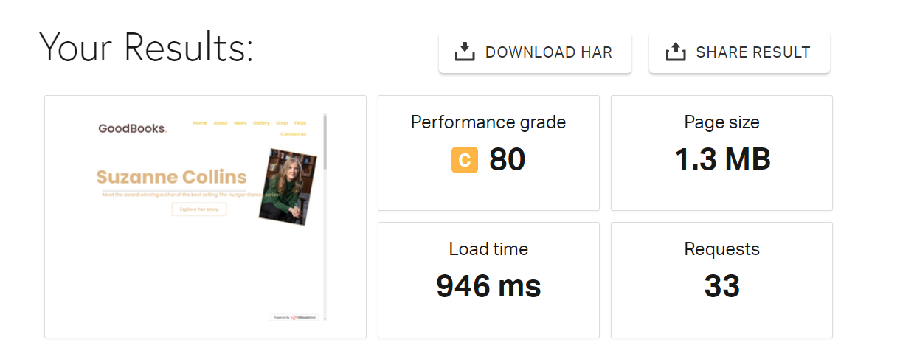

Figure 80.0

**News**

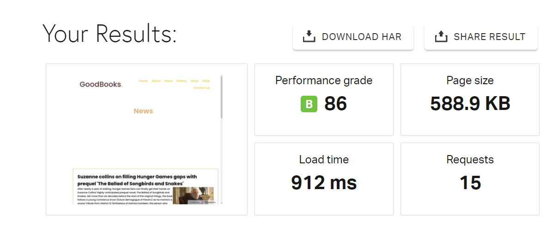

Figure 81.0

**About**

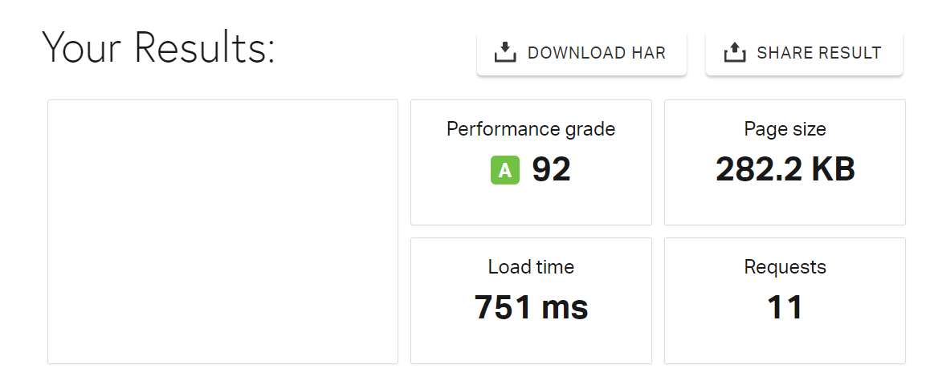

Figure 82.0

**Gallery**

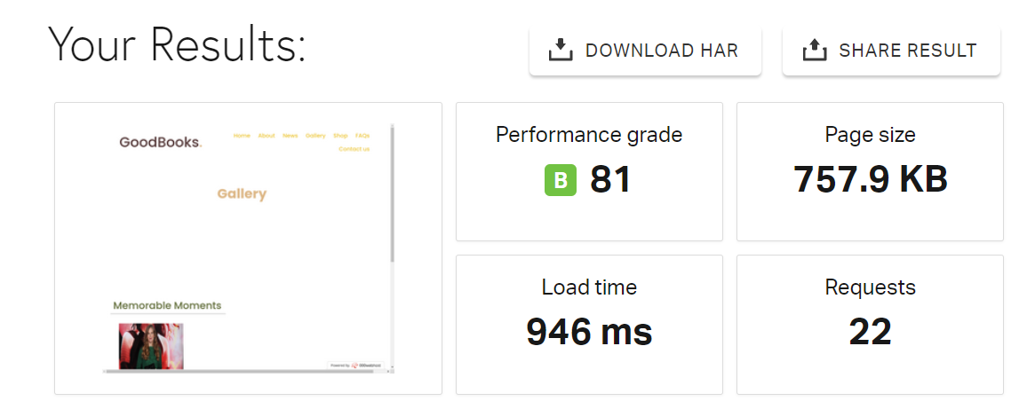

Figure 83.0

**News**

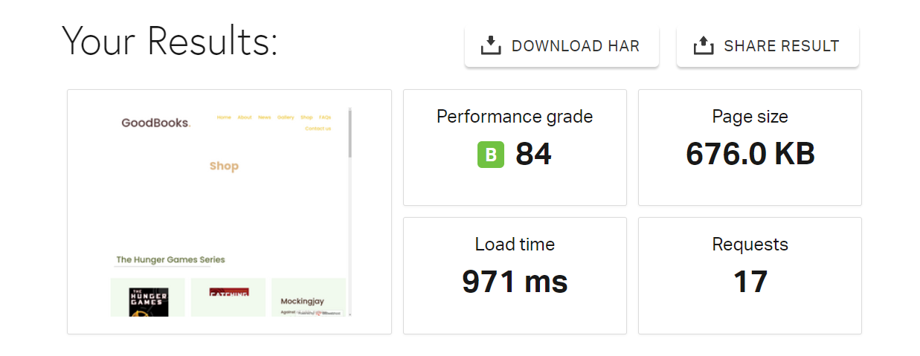

Figure 84.0

**FAQs**

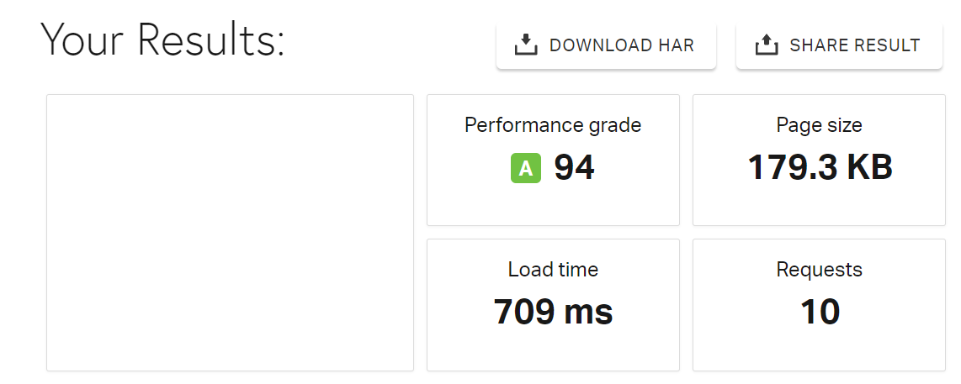

Figure 85.0

**Contact us**

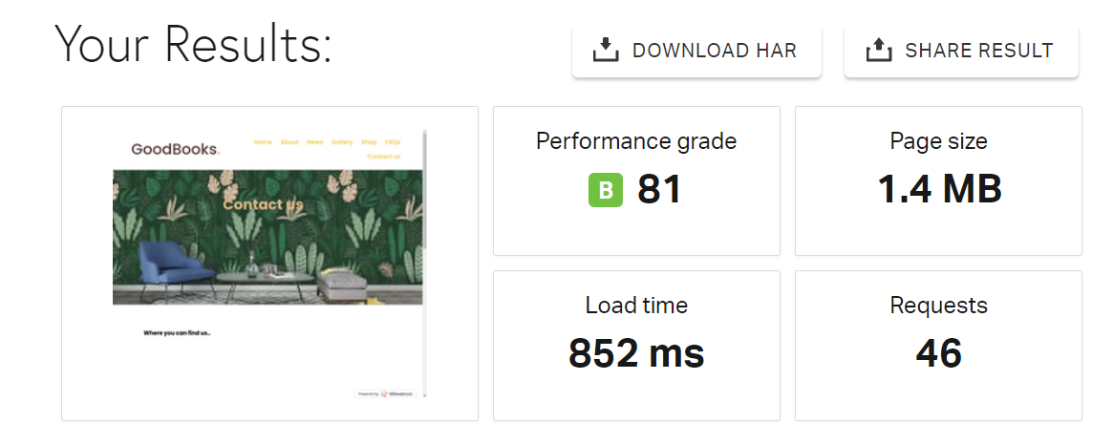

Figure 86.0

As can be observed by the screenshots above, the performance grade of all the main pages of this website is 80 and above. This is a good performance grade and the loading time of the website is also in milliseconds, therefore it can be concluded that the website is generally fast and has a good performance.

Responsive Testing

A good website has to be responsive as many other devices apart from desktops such as tabs and smartphones are widely popular in this day and age, therefore a website has to adjust itself according to the screen size of a device. Responsive testing ensures that a website offers optimal experience to the user regardless of their devices.

**Home page**

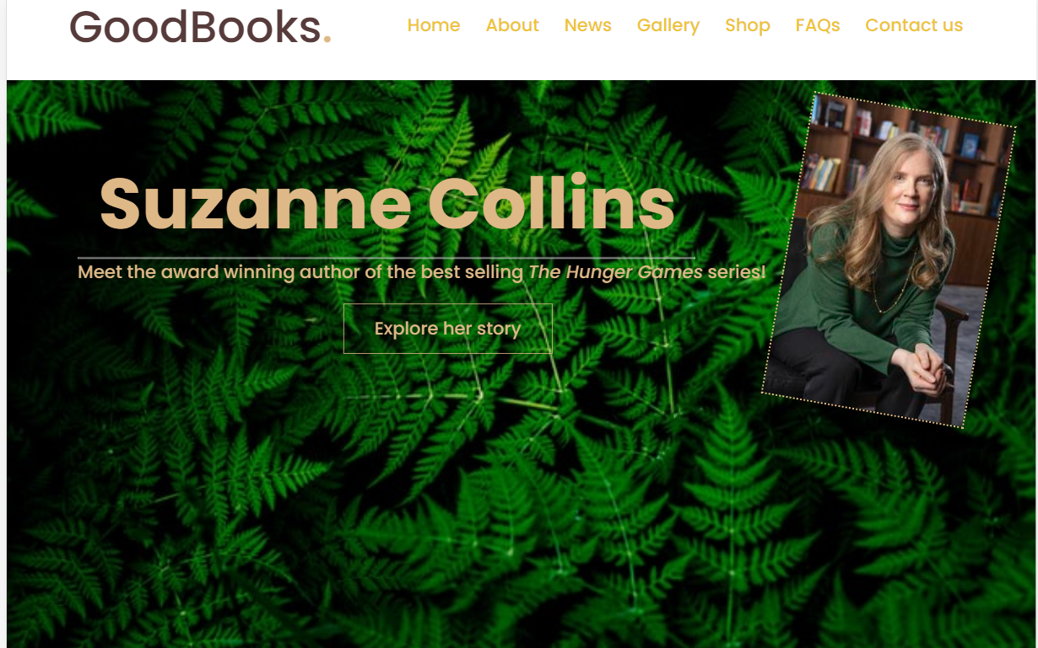

Figure 87.0

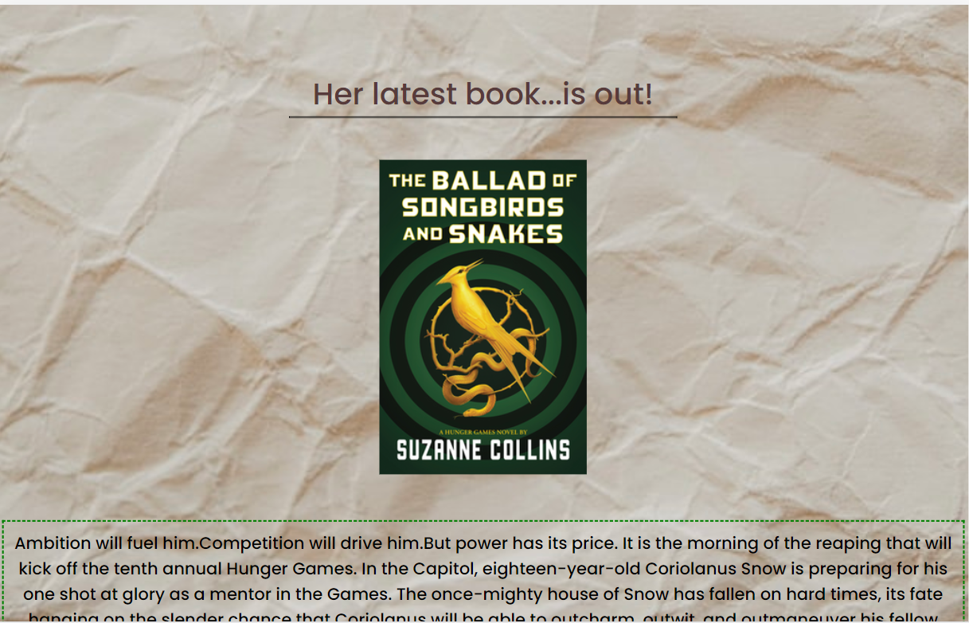

Figure 88.0

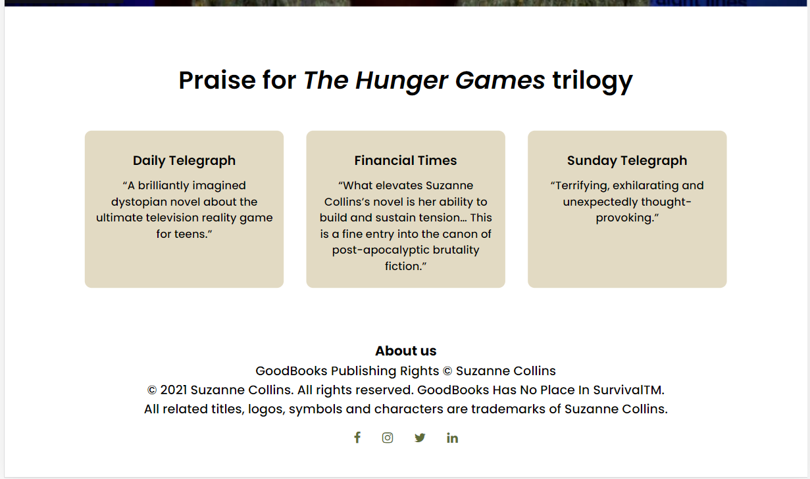

Figure 89.0

These are some screenshots of the home page when the screen is at 1160px. This is the desktop view.

And below are some of the screenshots of the home page when the screen is 600 px or less.



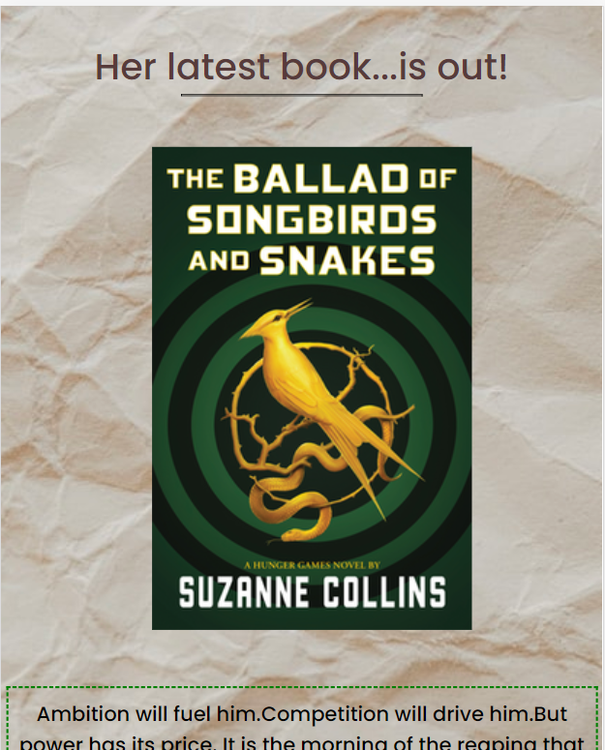

Figure 91.0

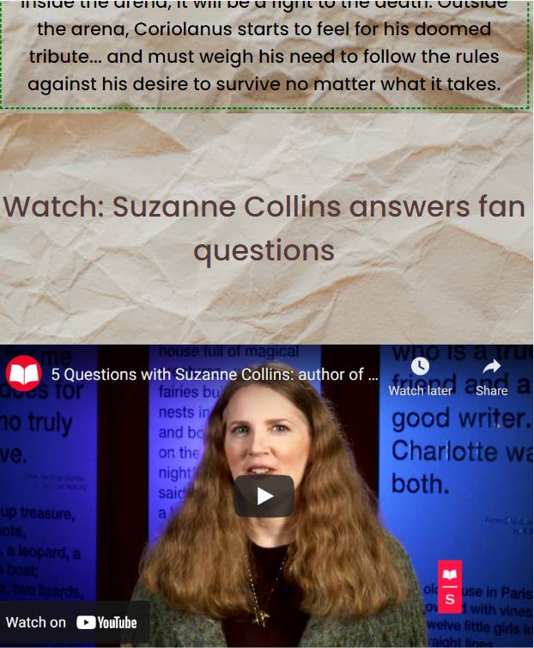

Figure 92.0

**About page**

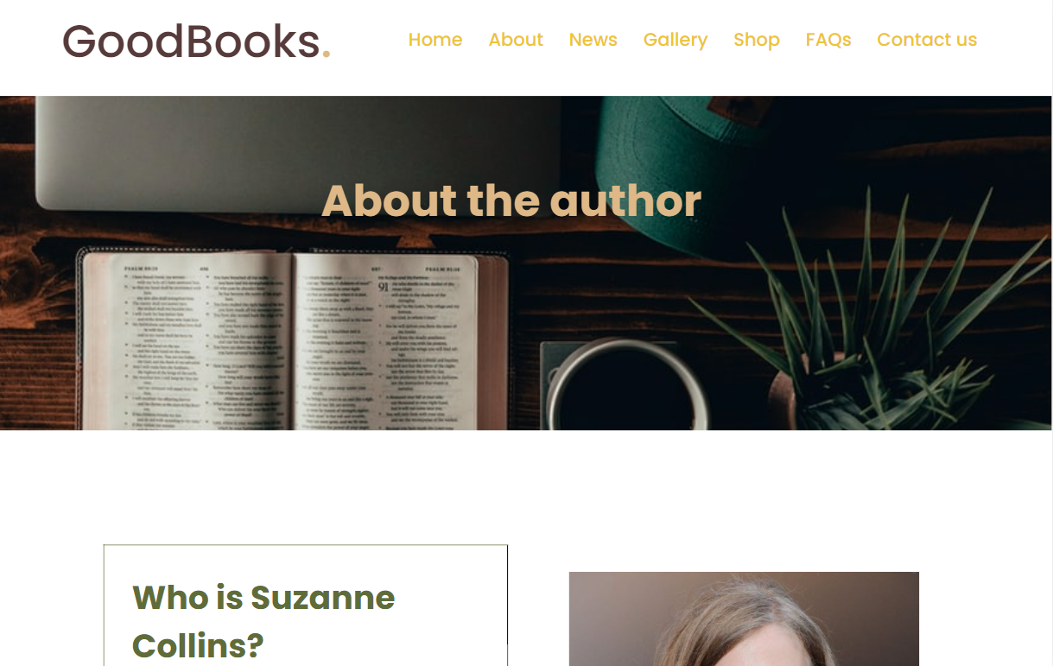

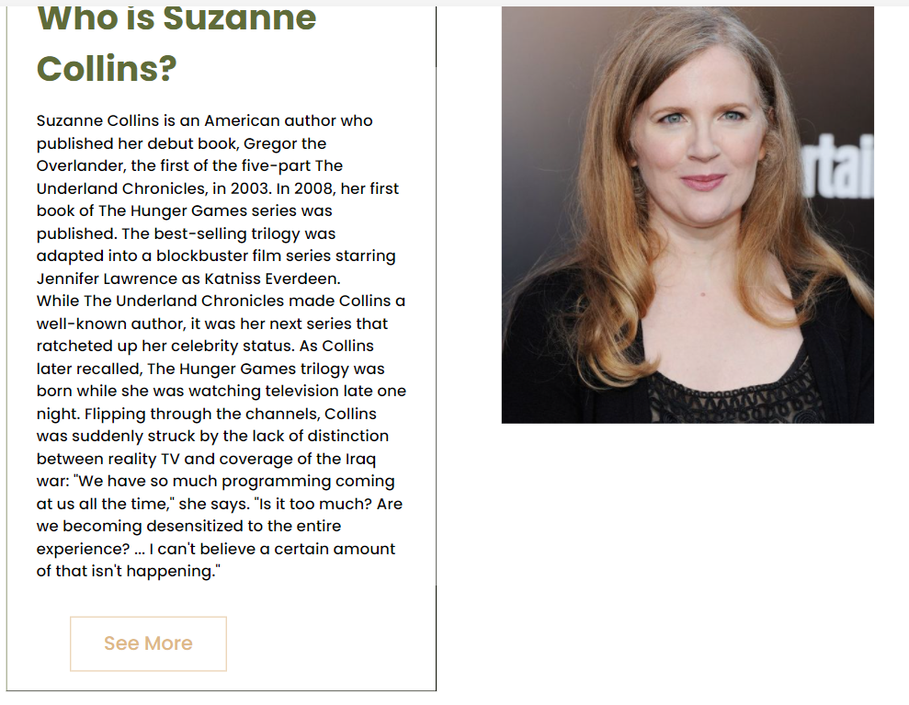

Figure 93.0

This is the desktop view of the “About” page. The screen size is at 1160 px.

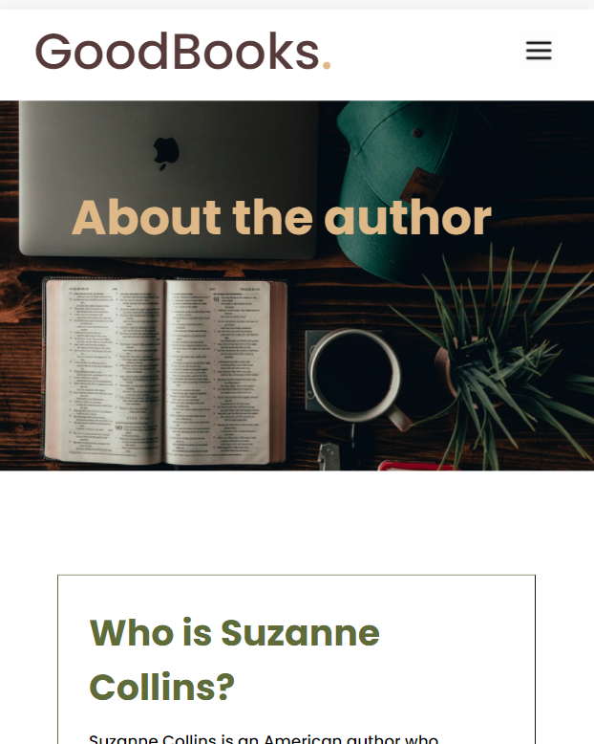

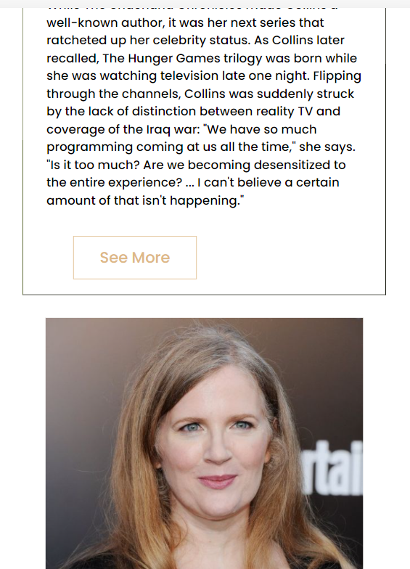

Figure 94.0

This is the view of the “About” page when the screen is 600 px or less (mobile view)

**News**

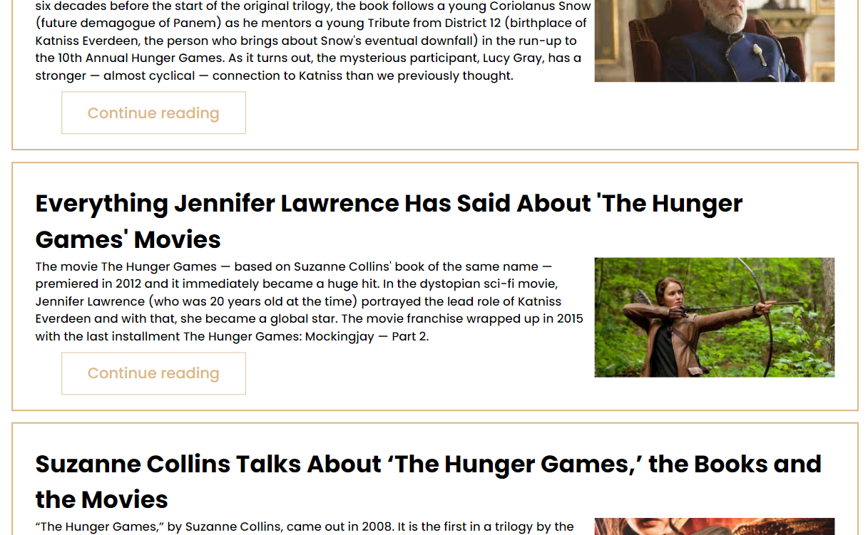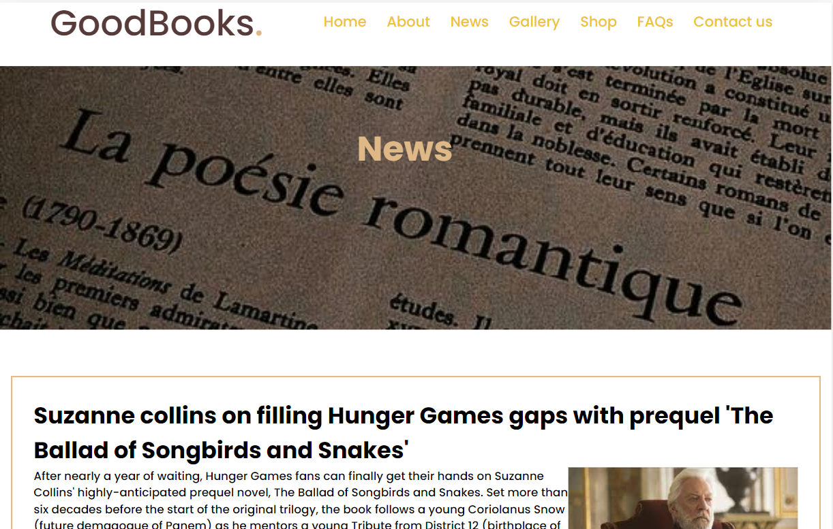

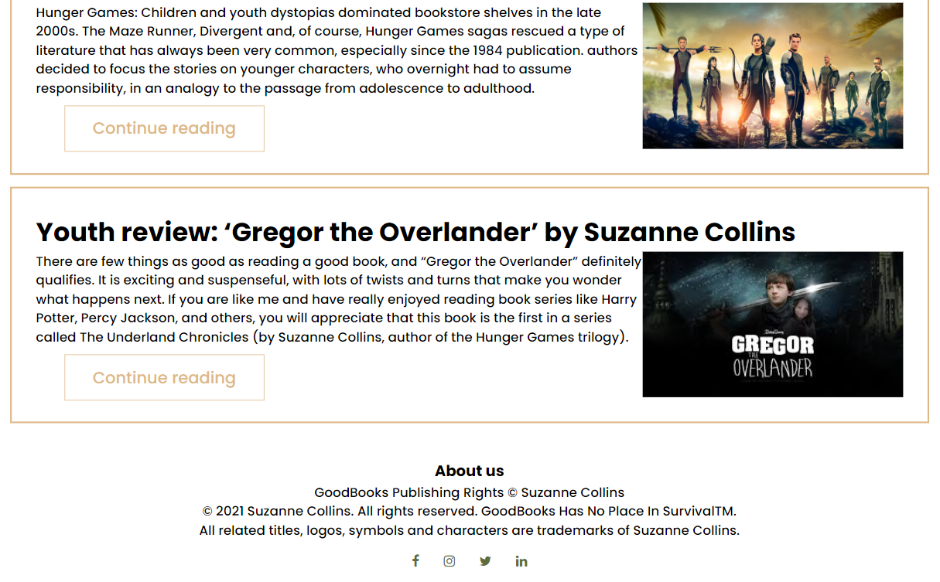

Figure 95.0

This is the view of the News page in desktop view, when the screen size 1160 px.

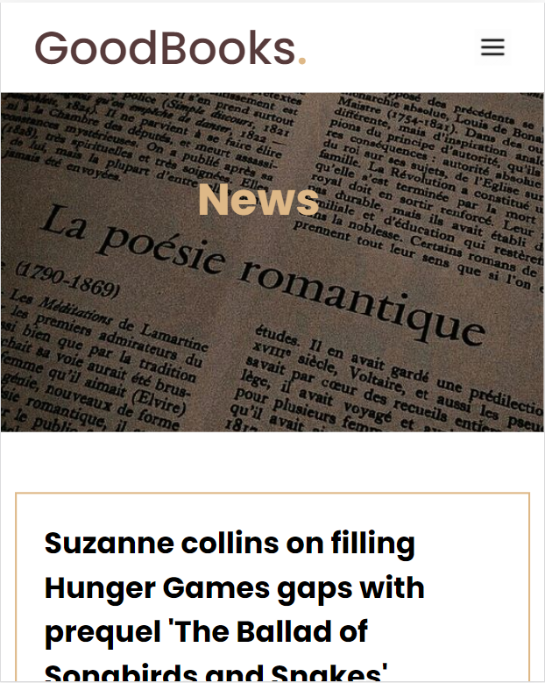

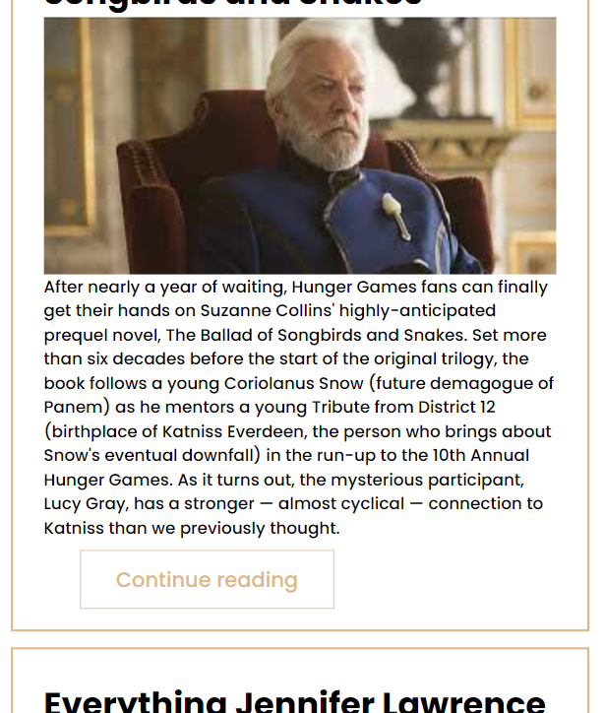

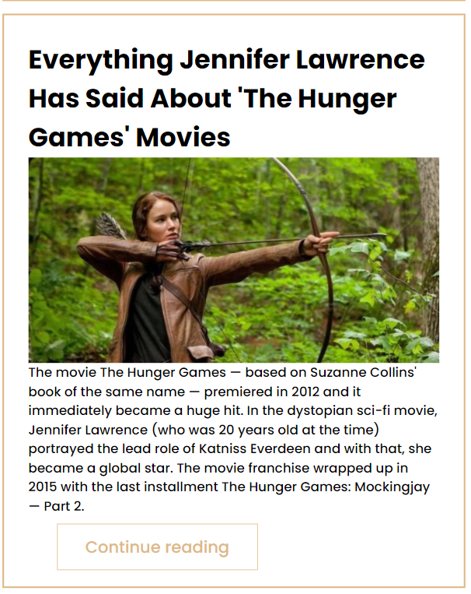

Figure 96.0

These are a few screenshots of how the News adjusts to the screen when the screen size is 600px or less. This is how the website looks on mobile.

**Gallery**

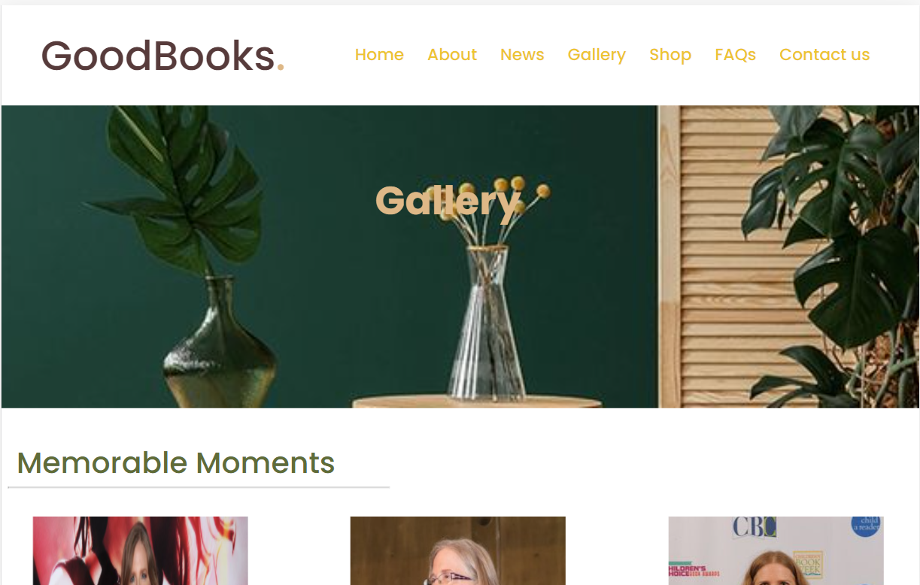

Figure 97.0

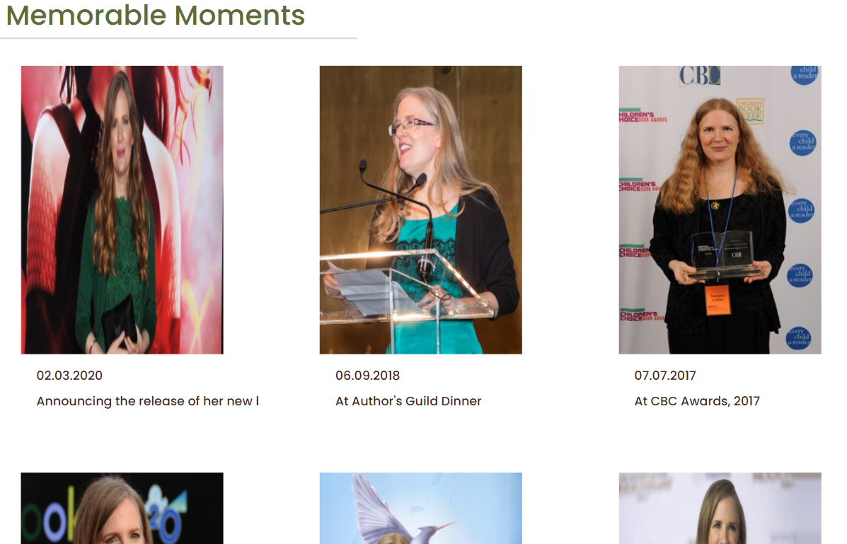

Figure 98.0

These screenshots show the Gallery page when the website is views on desktop. The screen size is 1160 px.

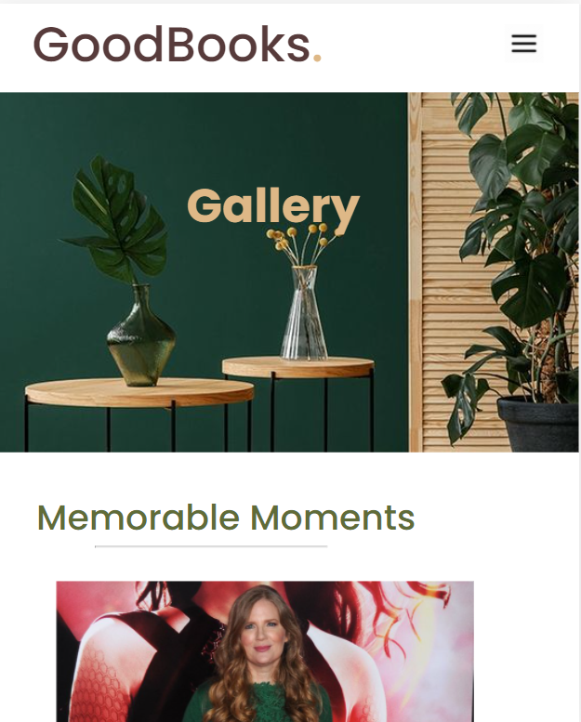

Figure 99.0

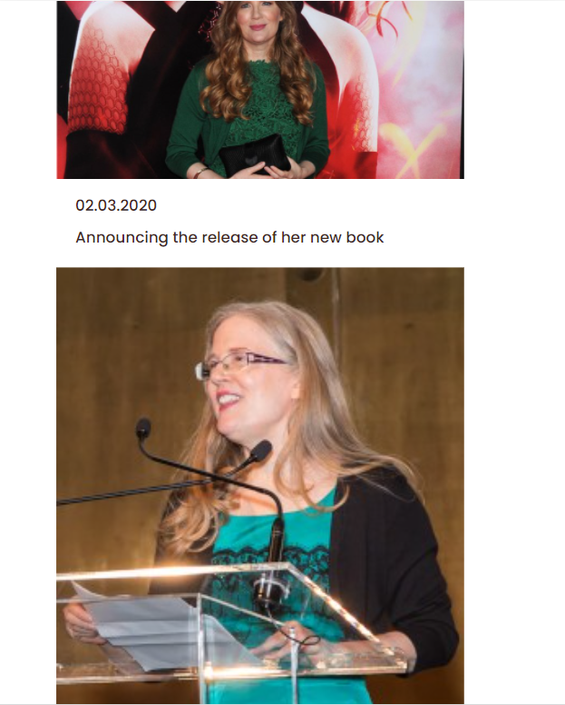

Figure 100.0

This is the mobile view of the Gallery page when the screen size is 600px or less.

**Shop**

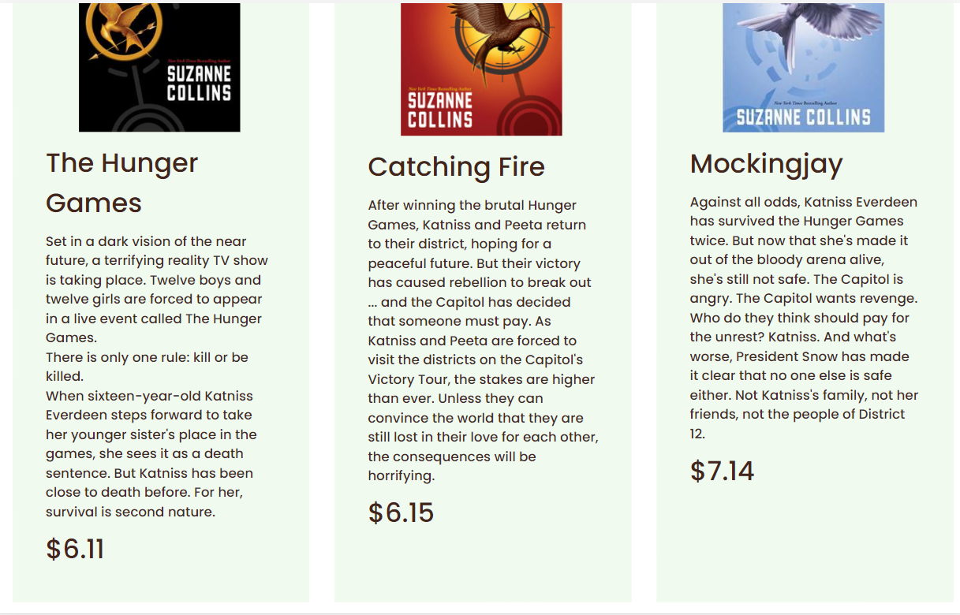The desktop view of the “Shop” page when the screen size is 1160 px.

Figure 101.0

Figure 102.0



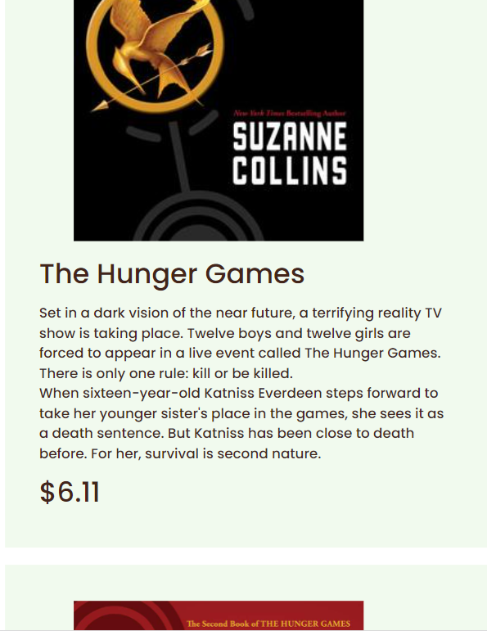

Figure 103.0

The mobile view of the “Shop” page when the screen is 600px or less.

**FAQs**

Desktop view of the “FAQs” page (screen size 1160px)

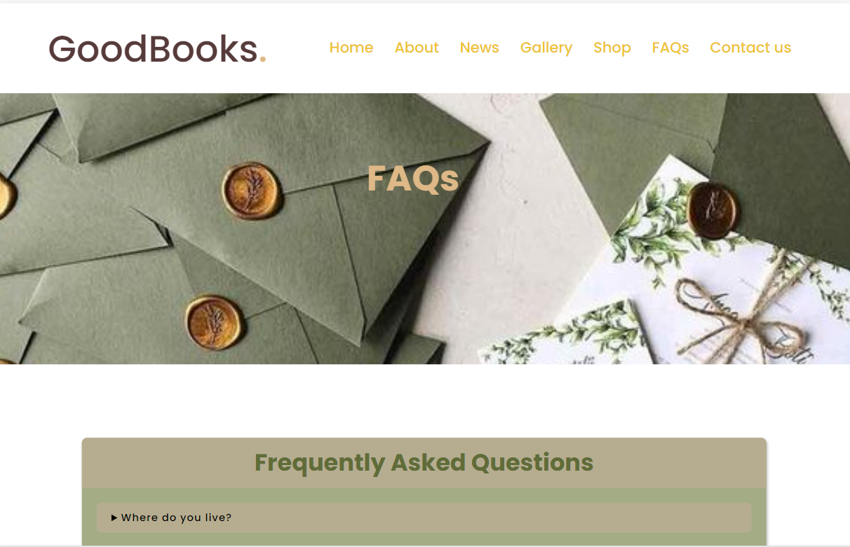

Figure 104.0

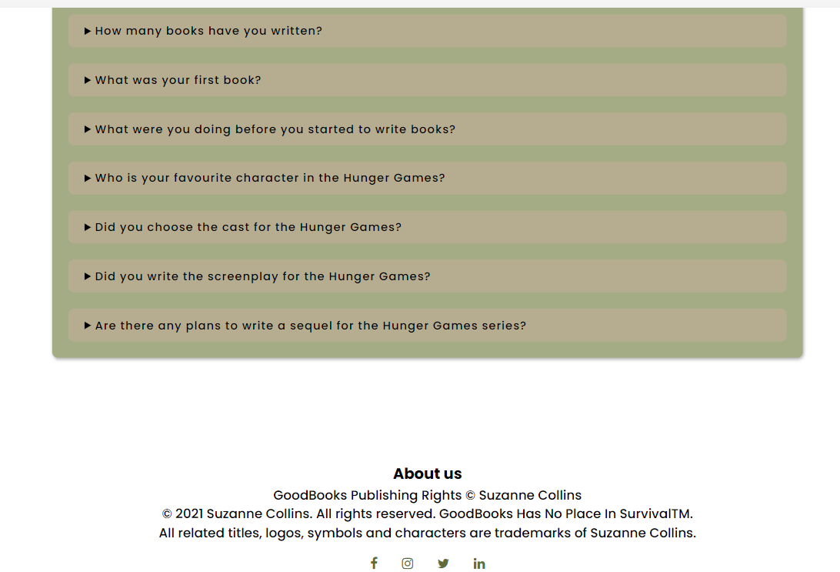

Figure 105.0

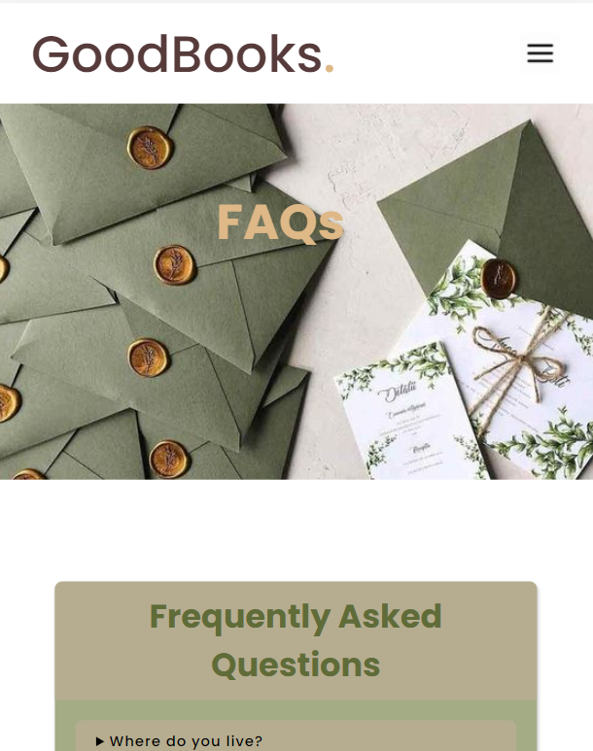The mobile view of the FAQ page when the screen size is 600px or less.

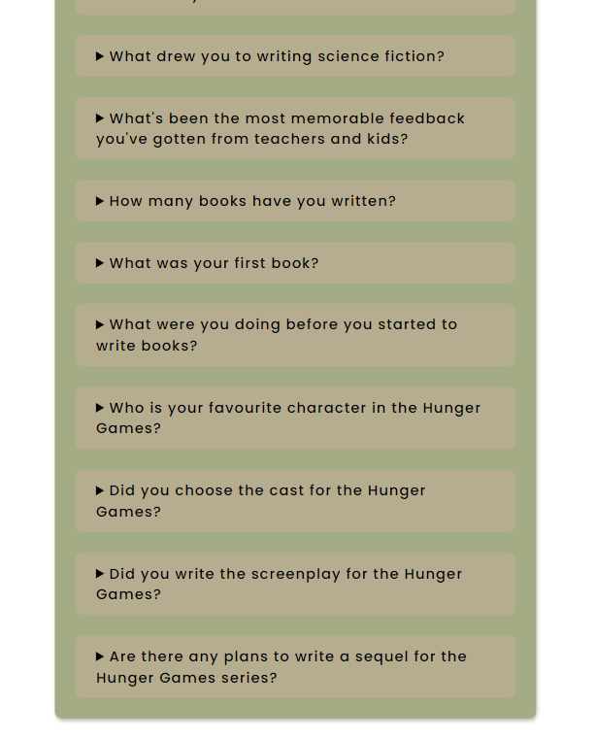

Figure 106.0

**Contact us**

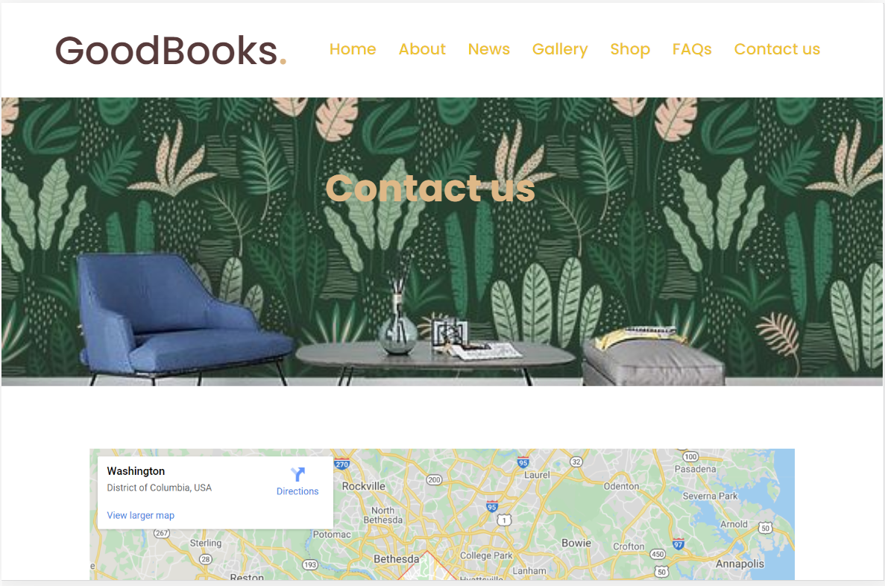

Figure 107.0

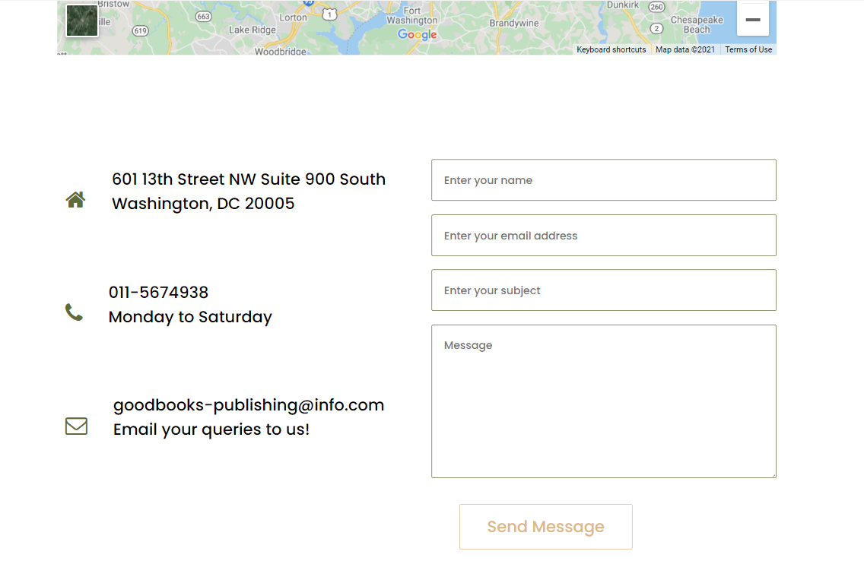

Figure 108.0

The desktop view of the page when the screen size is 1160 px. Below are screenshots of the page when the screen size is 600px or less.

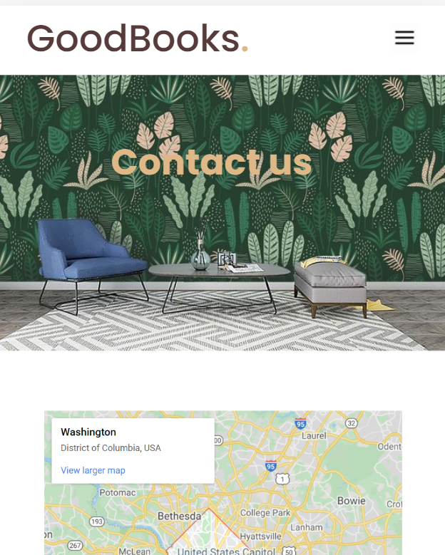

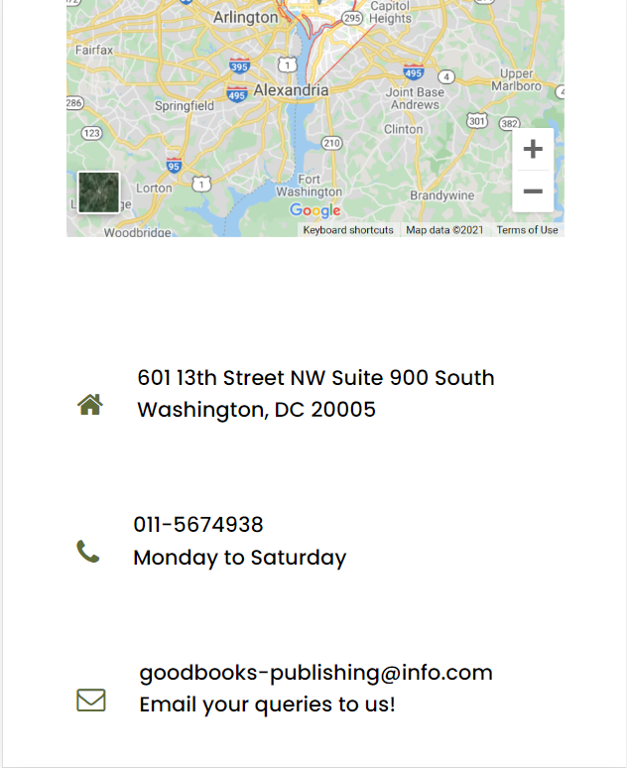

Figure 109.0

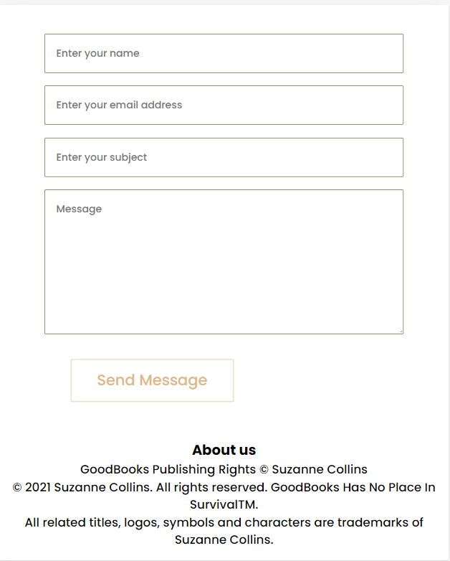

Figure 110.0

Therefore as seen above, it can be concluded that the website is responsive and adjusts to the screen size of the devices accordingly.

**Conclusion and Recommendations**

The website has been built successfully with the relevant assumptions. It has been made as user friendly as possible and it is also a responsive website. There is easy navigation to all the pages of the website. The errors that were shown when the website was checked for HTML validation have all be corrected as shown in the screenshots when the website testing was done. Numerous tests were conducted on the website to check its speed, performance, compatibility etc. and it has been deemed a considerably good website in terms of performance. The website has all the main requirements that was needed from it and also an additional FAQ page to make the website more lively and interactive. The website has been designed according to the design plan and the wireframes drawn beforehand, and it can be concluded that it is a highly user friendly and an interactive website.

In future, more pages can be added to the website such as “Events” or “Author’s blog” to improve the users experience in the website by giving them useful content. Further, the performance, speed and compatibility of the website can be improved and the issues can be corrected, to have a highly efficient website.

**Gantt chart**

|  |  |  |  |  |  |  |  |  |  |  |  |
| --- | --- | --- | --- | --- | --- | --- | --- | --- | --- | --- | --- |
|  | June | | | | | July | | | | | |
| Week | 1 | 2 | 3 | 4 | 5 | 1 | 2 | 3 | 4 | 5 |
| Assignment discussion |  |  |  |  |  |  |  |  |  |  |
| Assignment tasks |  |  |  |  |  |  |  |  |  |  |
| Task 1 |  |  |  |  |  |  |  |  |  |  |
| Task 2 |  |  |  |  |  |  |  |  |  |  |
| Task 3 |  |  |  |  |  |  |  |  |  |  |
| Task 4 |  |  |  |  |  |  |  |  |  |  |
| Task 5 |  |  |  |  |  |  |  |  |  |  |

# References

validator.github.io, n.d. *The Nu Html Checker (v.Nu).* [Online]   
Available at: https://validator.github.io/validator/  
[Accessed 18 July 2021].

WhatIs.com, n.d. *HTML Validator.* [Online]   
Available at: https://whatis.techtarget.com/definition/HTML-validator  
[Accessed 18 July 2021].